

CRM Accounting Invoice Quote

**User Manual**

# Table of Contents

Table of Contents 2

Introduction 3

Purpose 3

Intended Readers 3

System Responsibilities 3

Installation Instructions 4

System Overview 4

Hardware & Software Requirements 4

Installation of Software (Step-by-Step) 5

System Navigation 6

Registration 6

Login 9

Dashboard 10

Invoices 11

Payments 13

Customers 16

People 18

Companies 20

Leads 22

Quotes for Leads 24

Products 26

Products Category 28

Expense 30

Expense Category 32

System Reports 34

Settings 35

## **Introduction**

### **Purpose**

This document serves as theuser manual for the IDURAR ERP/CRM system. It explains how end-users can interact with the system, from installation to daily usage. It also outlines key workflows, navigation, and system capabilities in a concise and accessible format.

### **Intended Readers**

This manual is intended for:

* Business users managing invoices, clients, inventory, and HR
* Administrators managing system configuration
* IT support staff involved in installation and maintenance

### **System Responsibilities**

The system is responsible for providing an integrated ERP/CRM solution that enables

* Client management
* Invoice and quote generation
* Inventory tracking
* Payment processing
* Accounting summaries
* HR and employee data handling

## **Installation Instructions**

### **System Overview**

IDURAR is a MERN-stack-based ERP/CRM solution.

* **Frontend**: React.js + Redux + Ant Design
* **Backend**: Node.js + Express.js
* **Database**: MongoDB
* **Auth**: JWT token-based login
* **API**: RESTful APIs

### **Hardware & Software Requirements**

| **Component** | **Requirement** |
| --- | --- |
| OS | Linux (Ubuntu recommended) / Windows 10+ |
| RAM | Minimum 4 GB |
| Node.js | v16.x (with --openssl-legacy-provider) |
| MongoDB | v4.2 or above |
| Browser | Chrome, Edge, Firefox |

### 

### 

### 

### 

### 

### 

### **Installation of Software (Step-by-Step)**

1. **Clone the Repository**Run the below commands on CMD/terminal
   1. git clone <https://github.com/idurar/idurar-erp-crm>
   2. cd idurar-erp-crm
2. **MongoDB Setup**
   1. Ensure MongoDB is running locally or accessible remotely.
   2. Create a database named **idurar_app**.

Update **backend/.env** with your DB credentials.

1. **Backend Setup**
   1. cd backend
   2. npm install
   3. npm run seed # Optional: seed default data
   4. npm run start:dev # or use pm2 for production
2. **Frontend Setup** Open a new terminal:
   1. cd frontend
   2. npm install
   3. npm run dev # Starts on <http://localhost:3000>

## 

## 

## 

## 

## **System Navigation**

The System Navigation provides a unified interface to access all modules within Idurar ERP/CRM. It features a sidebar with links to core functionalities like Invoices, Payments, Customers, Products, and Settings, ensuring efficient workflow across different user roles. Quick-access options and dynamic breadcrumbs help users stay oriented during usage.

### **Registration**

The registration screen allows new users to create an account in the system. Depending on the configuration, this may include setting up company details or user roles. This is the entry point for onboarding employees or clients into the ERP system.

1. Navigate to: <https://cloud.idurarapp.com/>  
     
   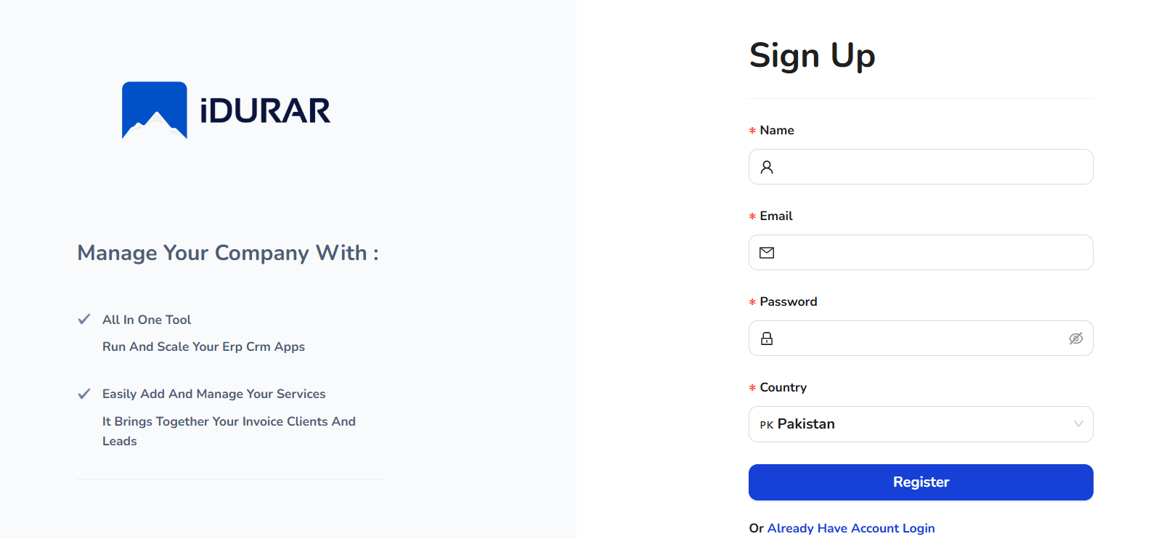
2. Enter the details.
3. Click on the Register button  
   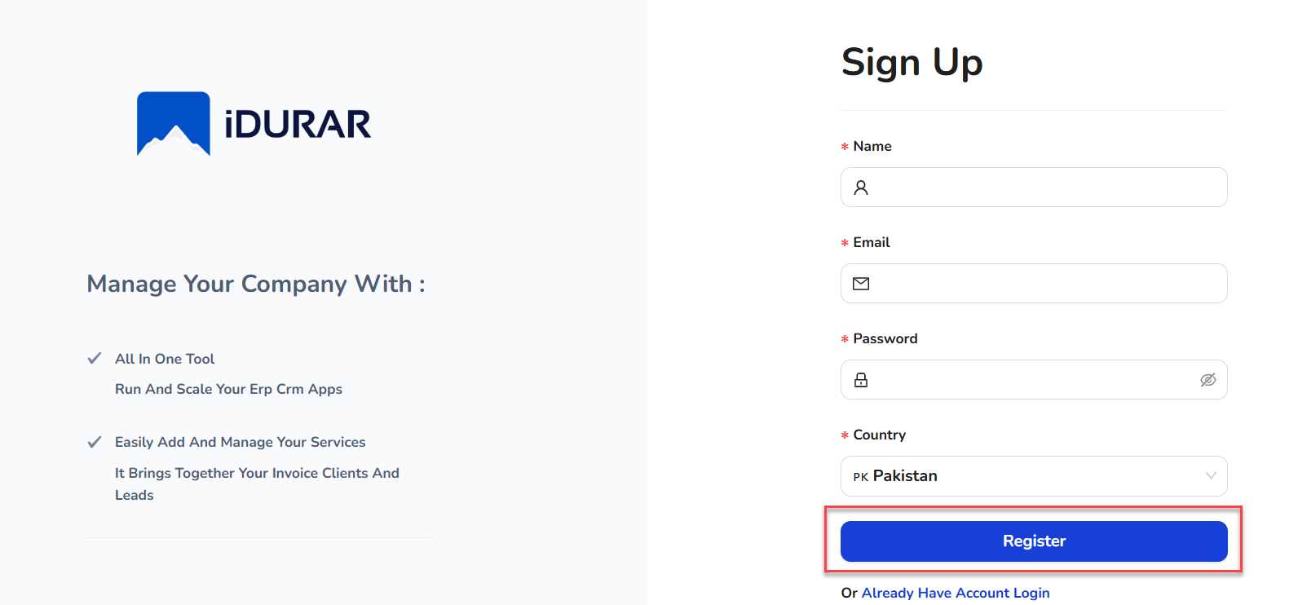
4. Users get a verification email.
5. Navigate to the inbox and open the email for verification.  
     
   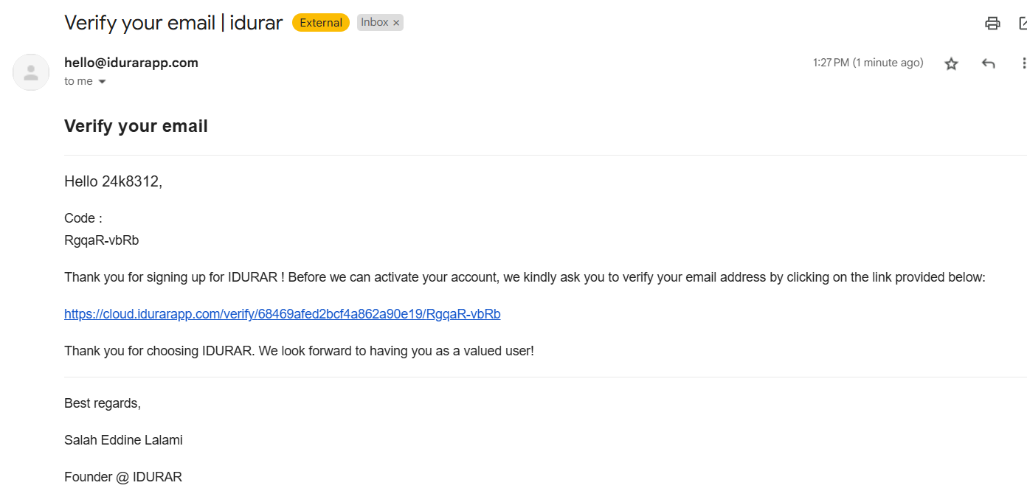
6. Click on the URL.
7. The verification code will auto-fetch.
8. Click on Verify Now button  
     
   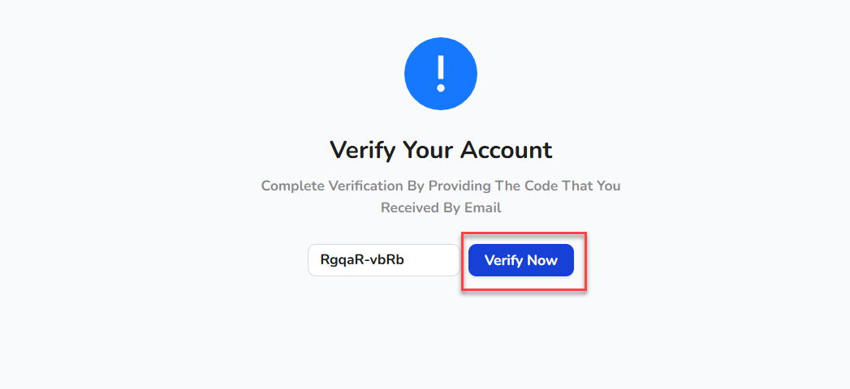
9. Once the account is created, the user will land on the Login page.

### **Login**

The login screen is the secure gateway for users to access the platform. It verifies user credentials and enforces authentication protocols. After successful login, users are redirected to the dashboard based on their role and permissions.

1. Navigate to: <https://cloud.idurarapp.com/login>
2. Enter credentials and click **Log In** button  
     
   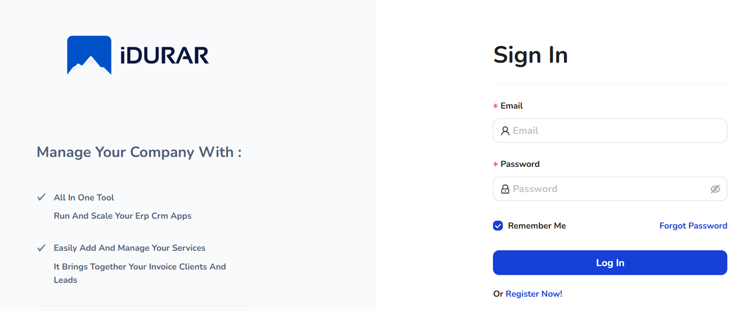
3. After logging in, you will enter see the dashboard (homepage), where you can discover the different entities that you can use accordingly.

### **Dashboard**

The dashboard provides a real-time overview of key business metrics, such as invoice statuses, revenue, customer activity, and expense tracking. This visual interface is designed to help users monitor performance and take immediate action based on data insights.

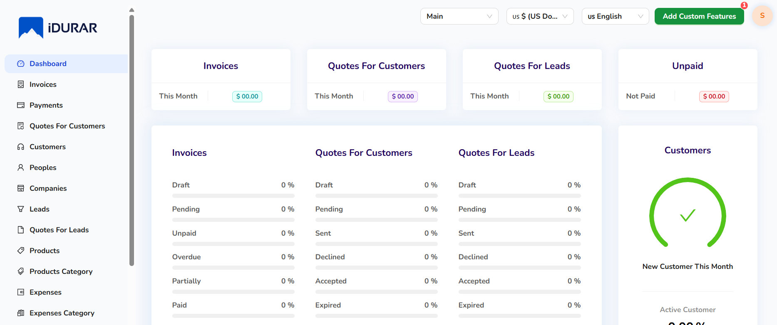

### **Invoices**

The Invoices module enables users to create, manage, and track invoices for products or services rendered. It supports payment status updates, PDF generation, and email dispatch. This module streamlines the billing process and helps maintain a clean revenue record.

1. To add invoices, from the left-side menu, select Invoices.  
     
   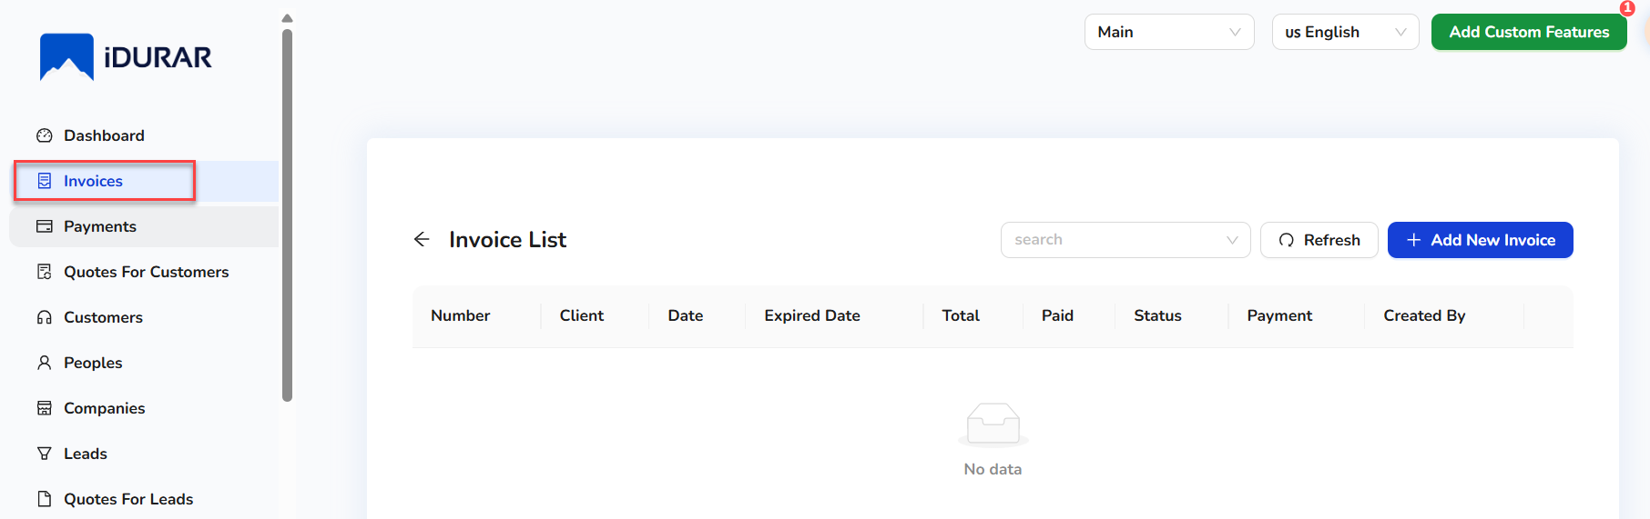
2. Users can see the existing invoice list.
3. To add the new invoice, click on the Add New Invoice button.  
     
   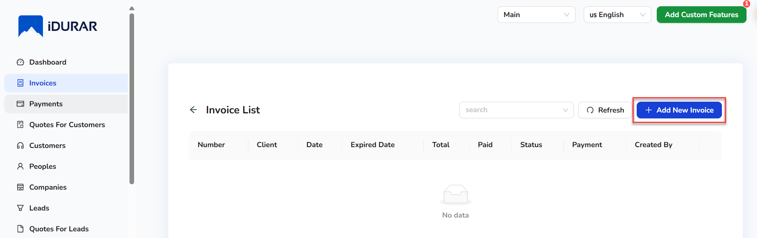
4. On clicking the Add New Invoice, a form will open.  
   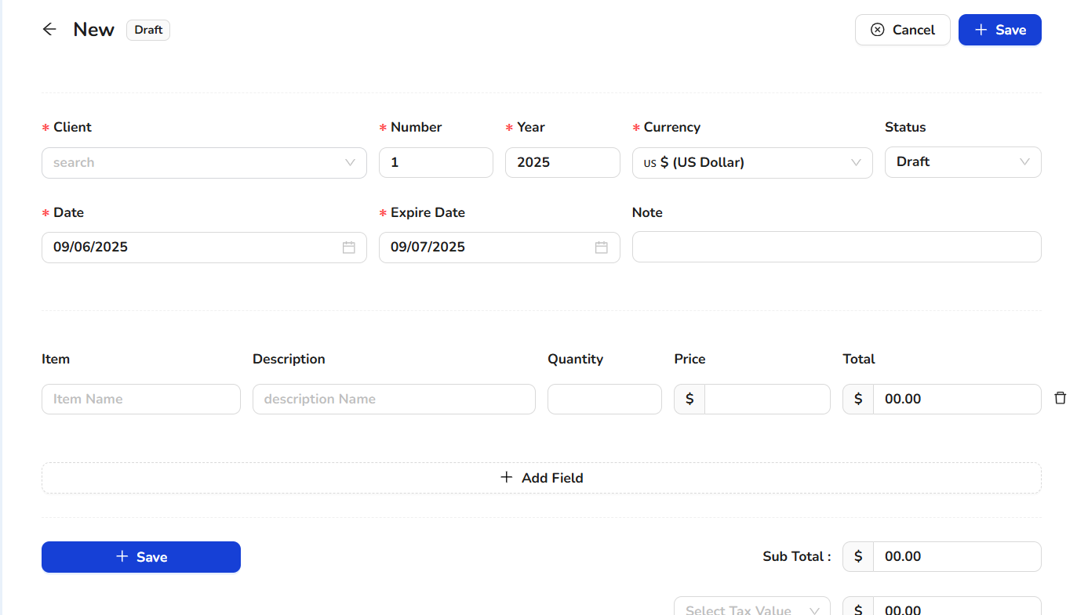
5. Enter the details.
6. Click on the Save button.  
     
   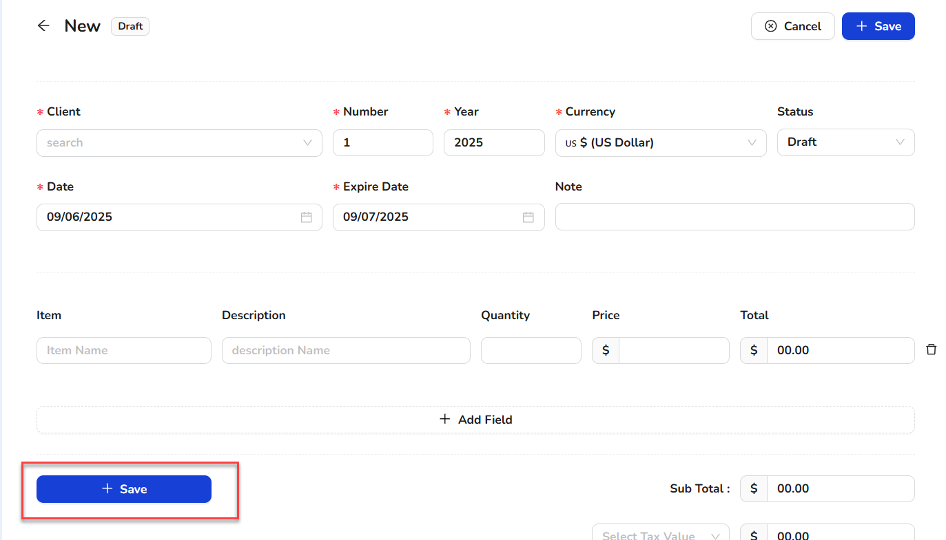
7. Once the new record is created, it will show in the invoice list.

### **Payments**

This screen is used to record and manage customer payments. It ties payments to specific invoices and updates outstanding balances. Users can track payment history and use it for financial reconciliation and reporting.

1. To view the payments, from the left-side menu, select Payments  
   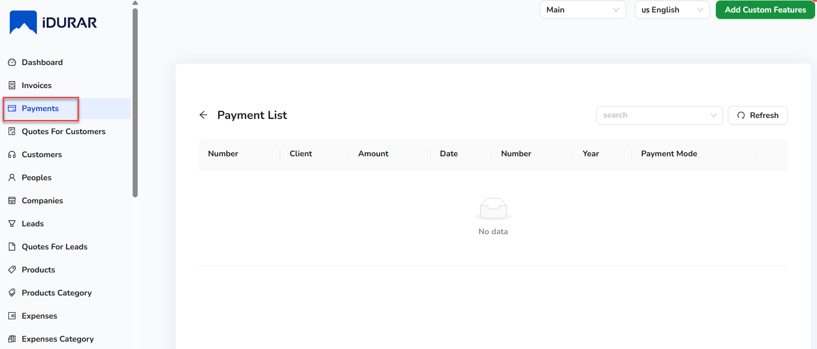.
2. Users can see the existing payment list.

**Quotes for Customers**

The Customer Quote module allows users to create formal price quotations for potential or existing customers. It serves as a pre-sales document detailing the products, services, pricing, terms, and validity period of the offer. Quotes can be converted into invoices upon customer approval, helping streamline the sales pipeline. This module is crucial for businesses that deal with custom orders, negotiated pricing, or need formal documentation before finalizing sales.

1. To add quotes for customers, from the left-side menu, select Quotes for Customers.  
     
     
   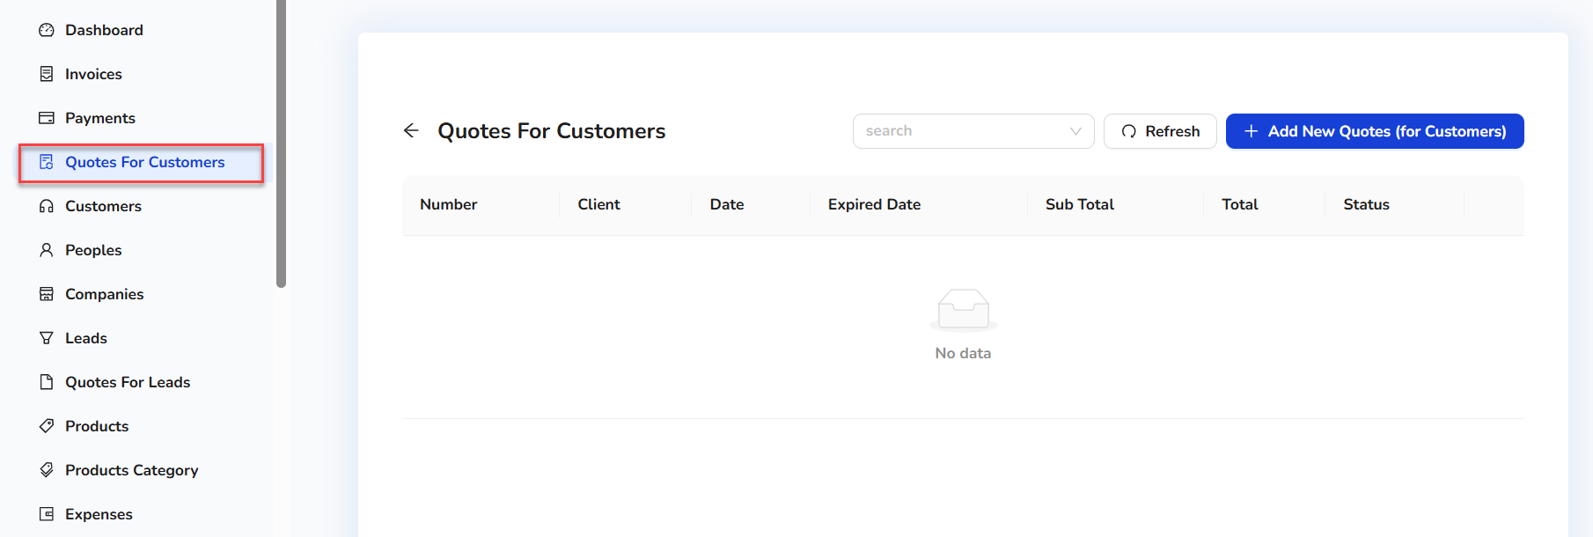
2. Users can see the existing Quotes for Customer list.
3. To add the new lead, click on the Add New Quote (for Customer) button.  
     
   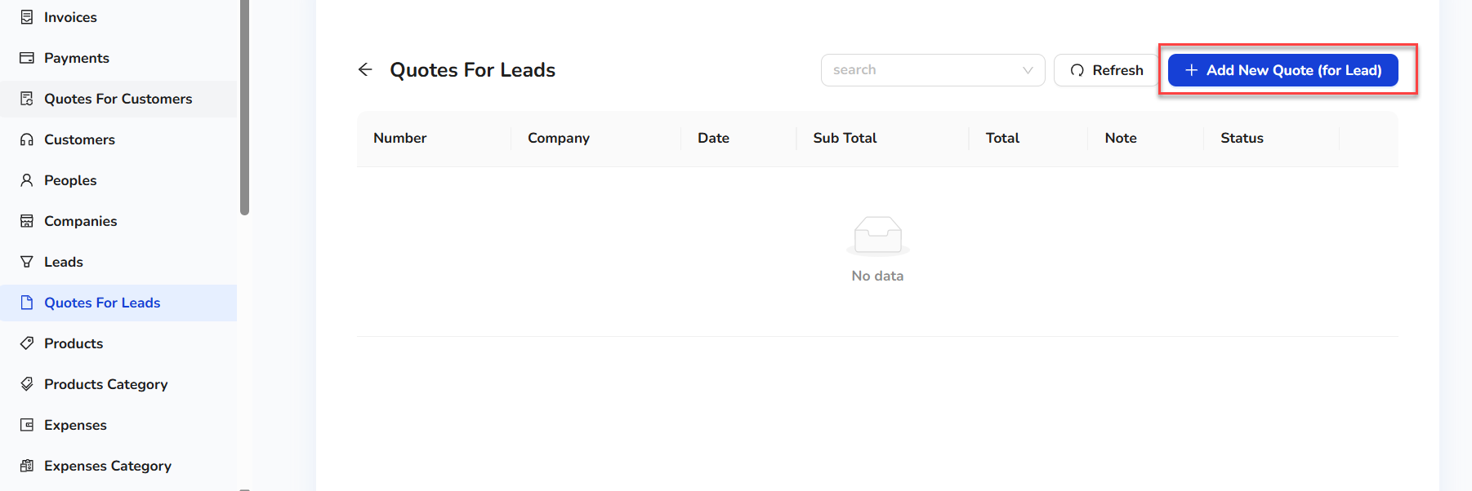
4. On clicking the Add New Quote (for Lead), a form will open.  
     
   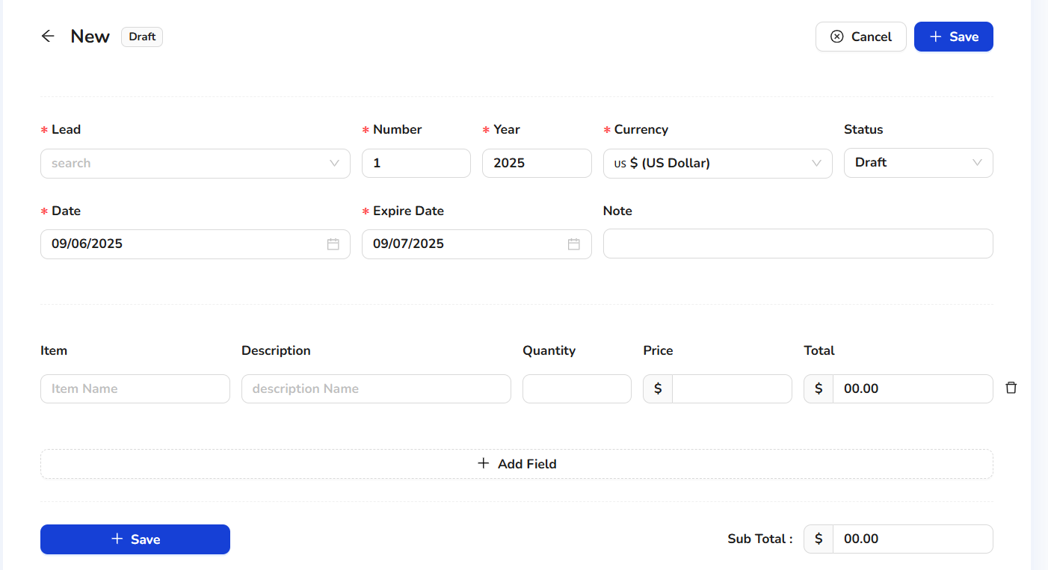
5. Enter the details.
6. Click on the Save button.  
     
   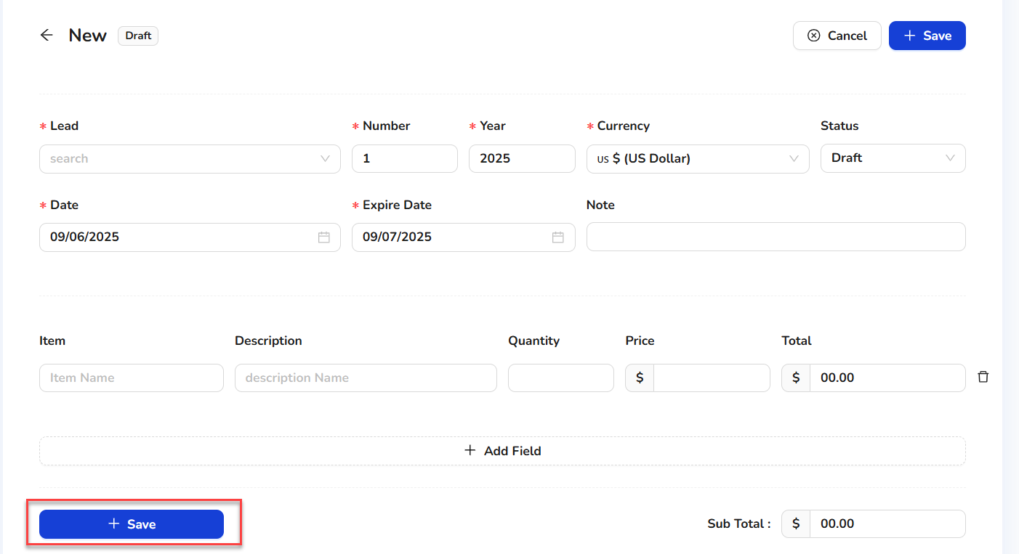
7. Once the new record is created, it will show in the Quotes for Lead list.

### **Customers**

The Customers module provides a centralized view of all client information. It supports CRUD operations on customer records and links them to their associated invoices, payments, and activity logs, helping teams manage relationships effectively.

1. To add customers, from the left-side menu, select Customers.  
     
   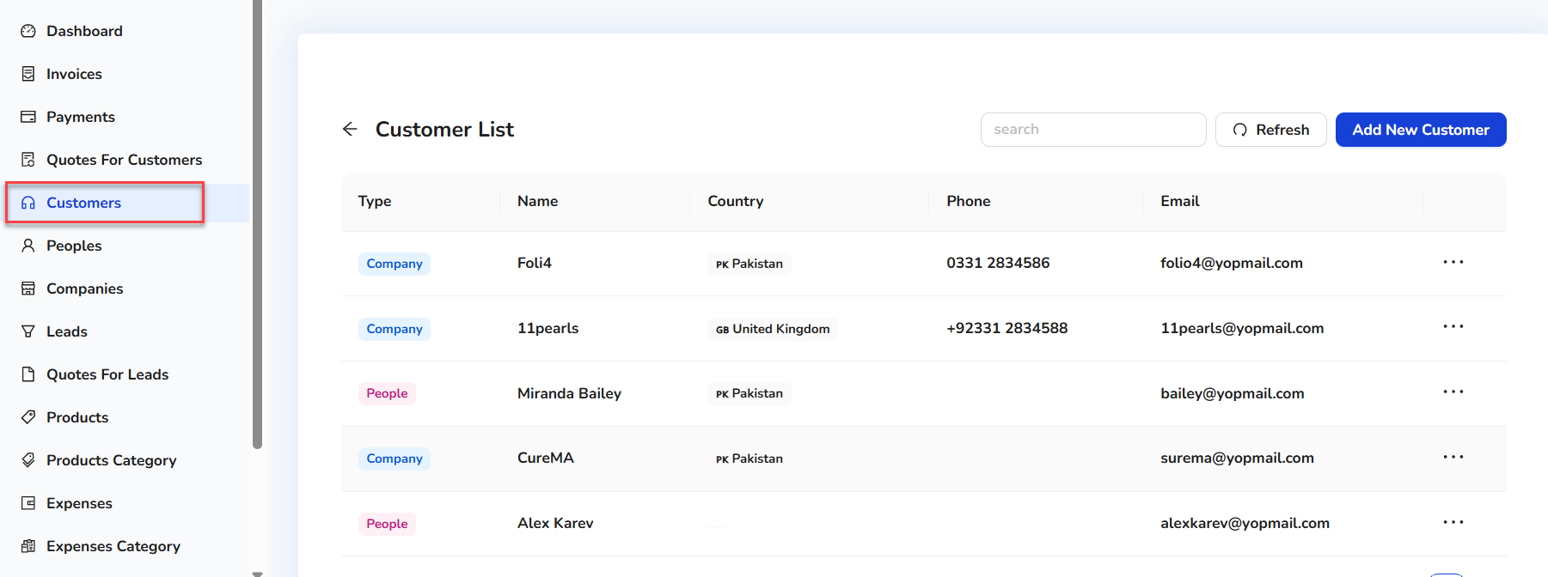
2. Users can see the existing customer list.
3. To add the new customer, click on the Add New Customer button.  
     
   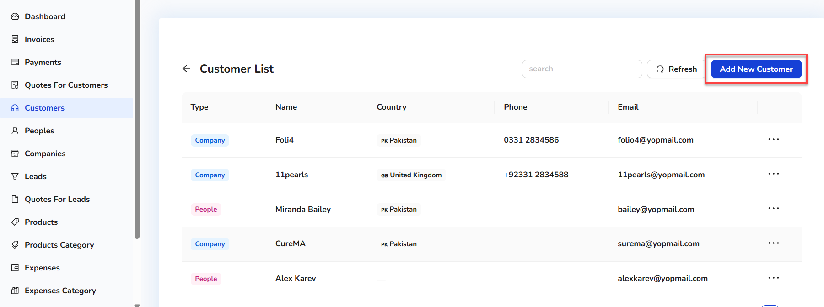
4. On clicking the Add New Customer button, a quick side form will open.  
   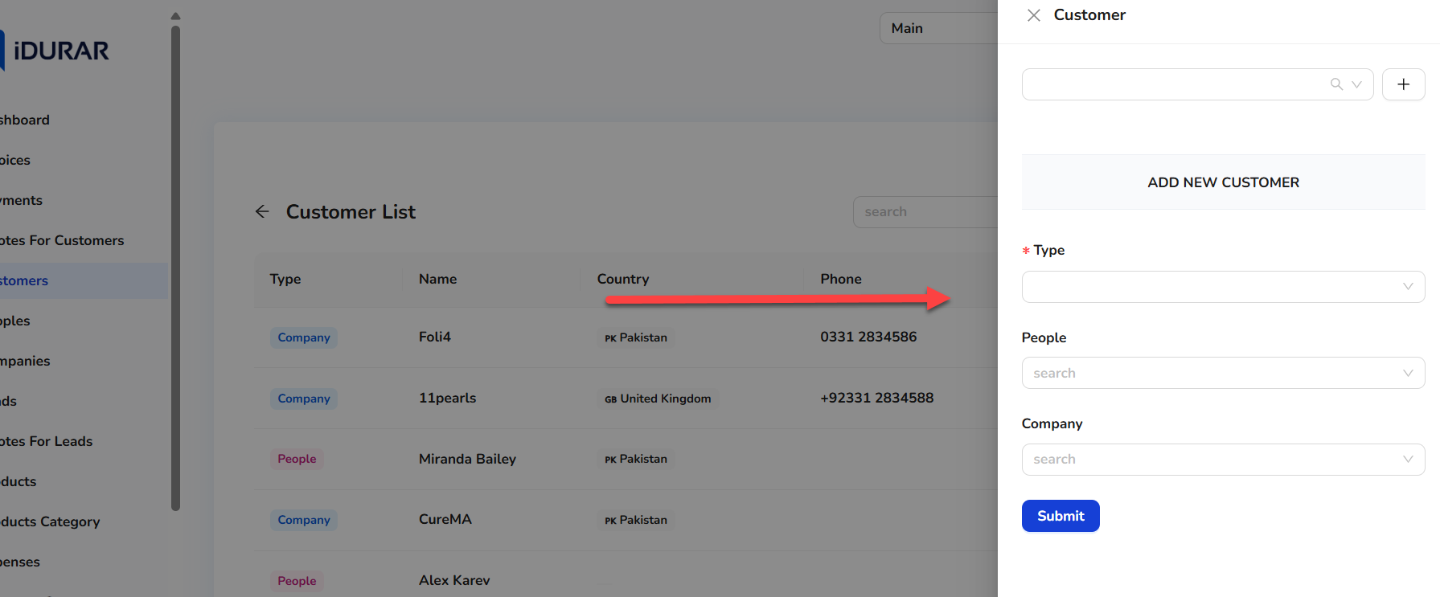
5. Enter the customer details.
6. Click on the Submit button  
   .  
   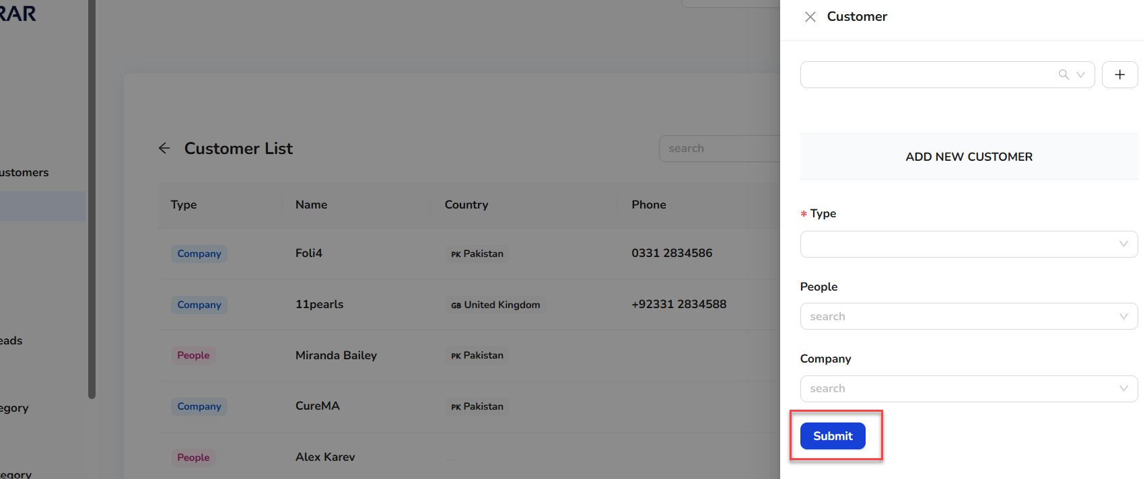
7. Once the new customer record is created, it will show in the customer list and customer lookups.

### **People**

The People screen manages user accounts within the organization, including employees and internal users. It supports assigning roles, setting access permissions, and managing user activity, critical for secure system operations.

1. To add people, from the left-side menu, select People.  
     
   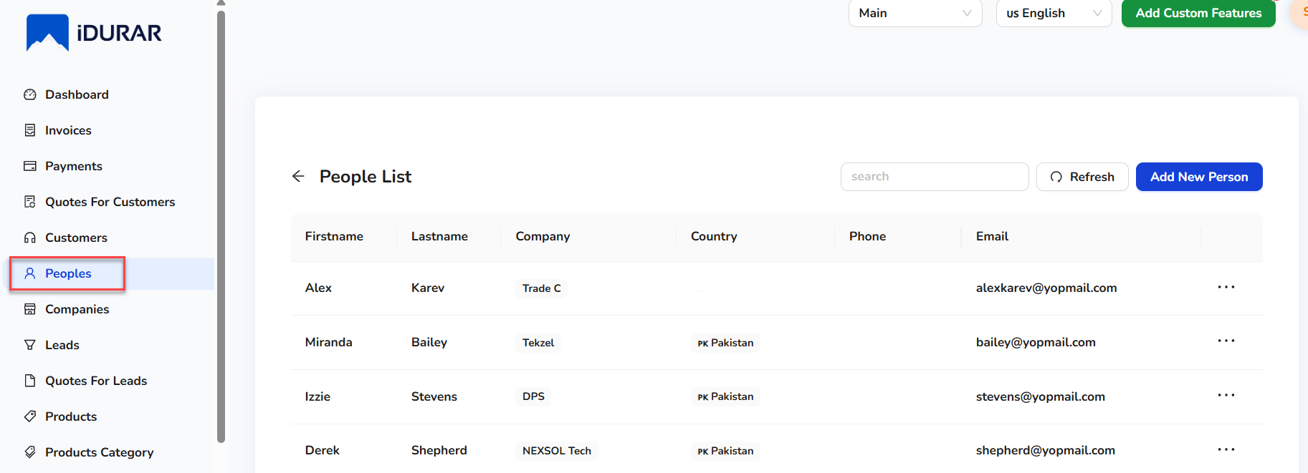
2. Users can see the existing People list.
3. To add the new customer, click on the Add New People button.  
     
   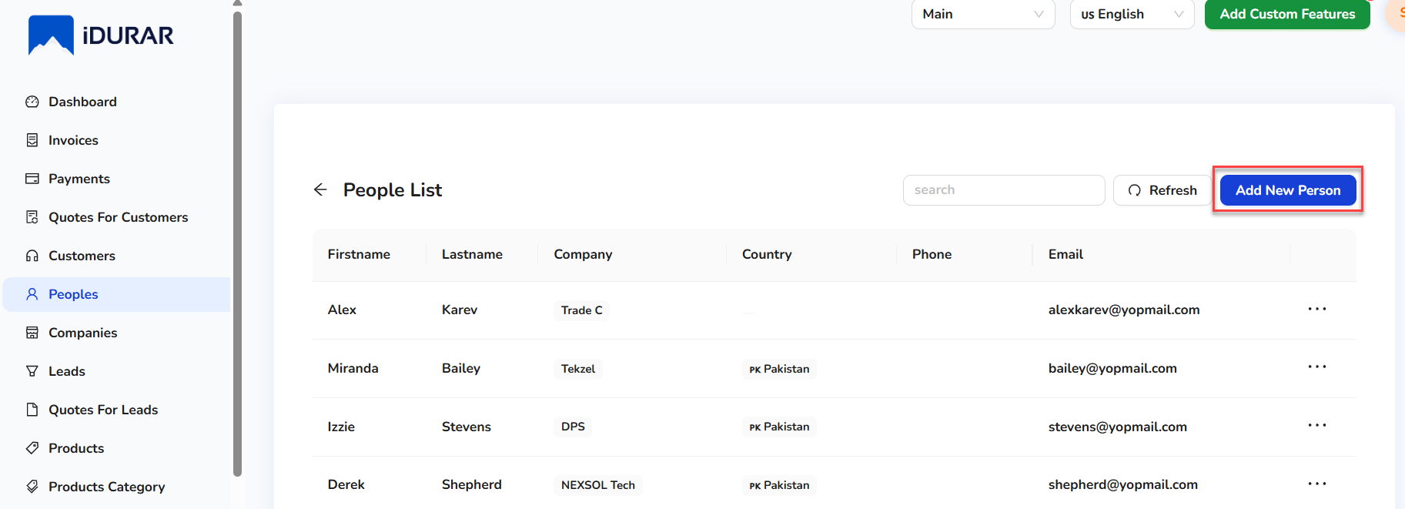
4. On clicking the Add New People button, a quick side form will open.  
   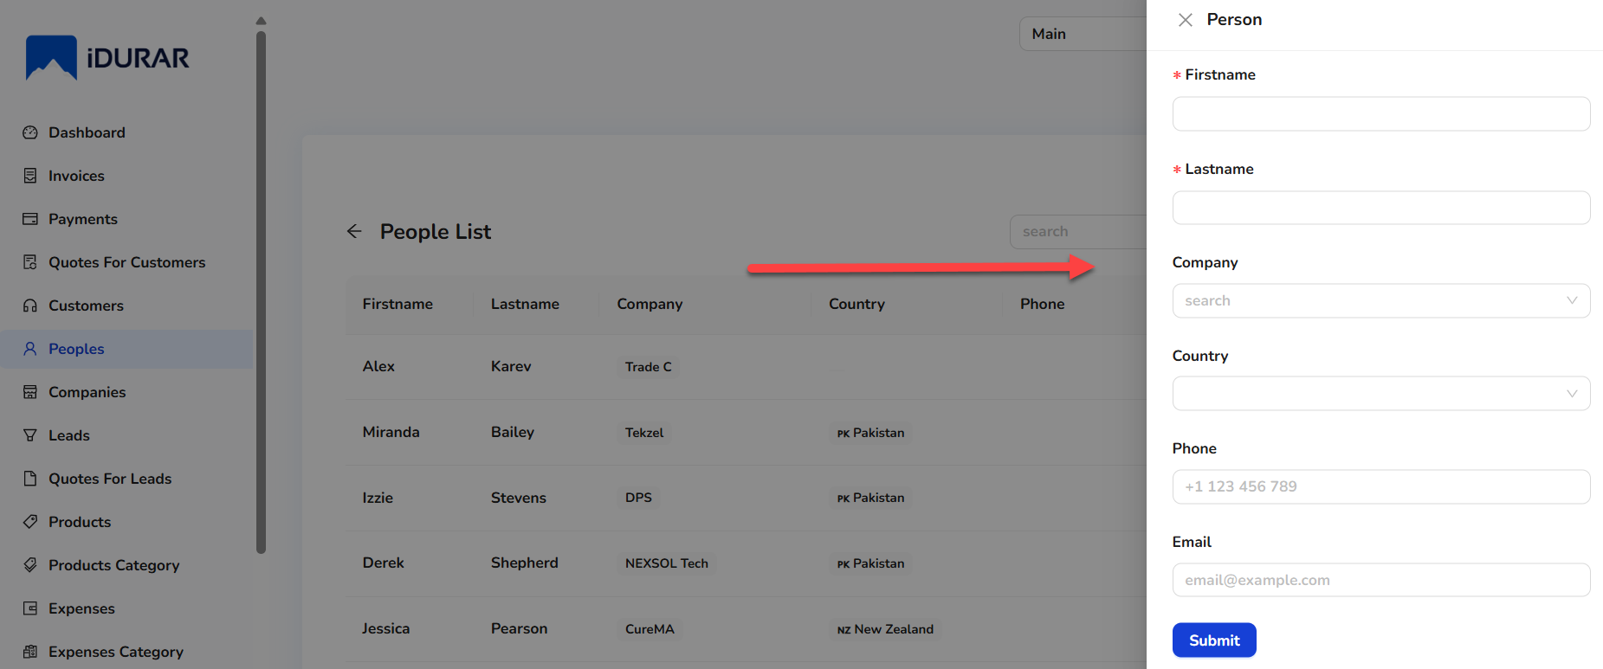
5. Enter the customer details.
6. Click on the Submit button.  
     
   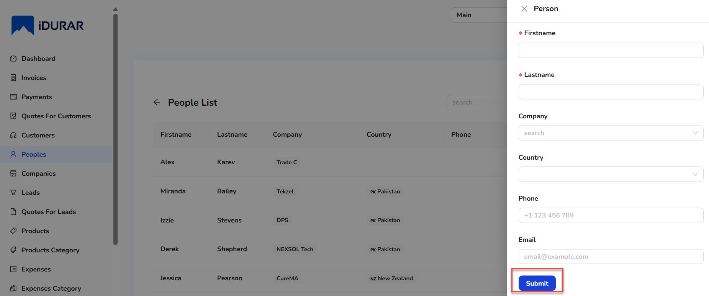
7. Once the new people record is created, it will show in the people list and people lookups.

### **Companies**

This section stores information about companies you interact with either as clients, vendors, or partners. It includes contact details, related people, and associated transactions.

1. To add a company, from the left-side menu, select Companies.  
     
   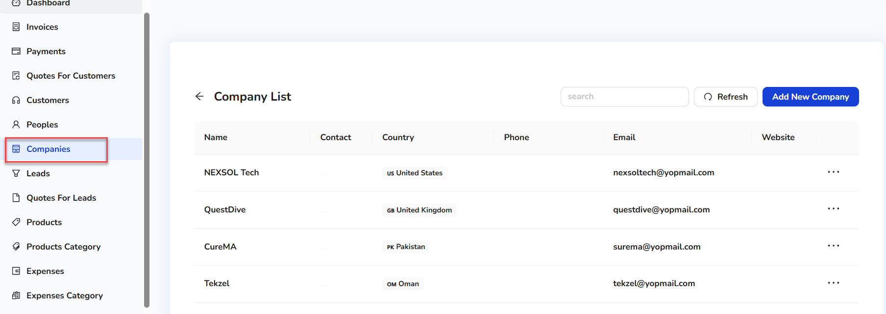
2. Users can see the existing company list.
3. To add the new company, click on the Add New Company button.  
     
   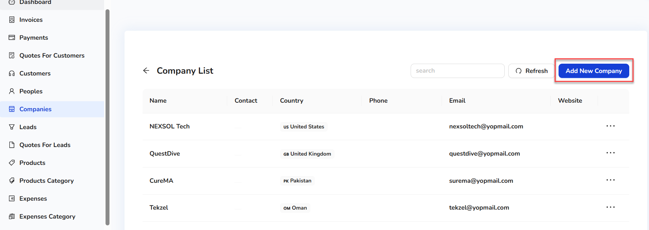
4. On clicking the Add New Company button, a quick side form will open.  
   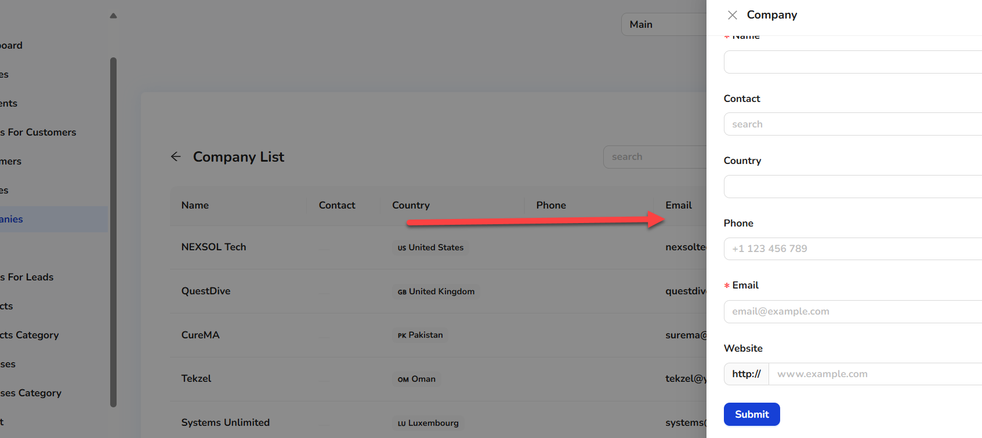
5. Enter the company details.
6. Click on the Submit button.  
     
   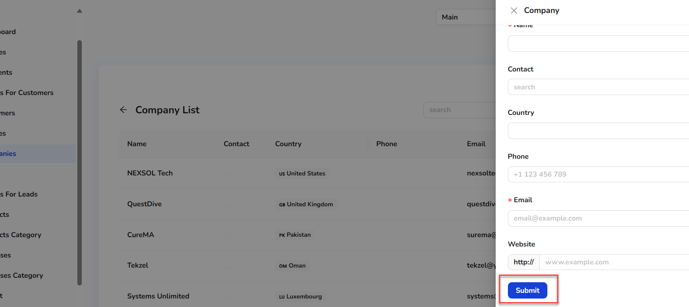
7. Once the new company record is created, it will show in the company list and company lookups.

### **Leads**

The Leads module is designed to help businesses manage and nurture potential clients or sales prospects. A lead typically represents an individual or organization that has shown interest in your products or services but has not yet become a customer. This module allows you to track interactions, follow-up tasks, and lead sources, making it easier to convert them into paying customers.

1. To add leads, from the left-side menu, select Lead.  
     
   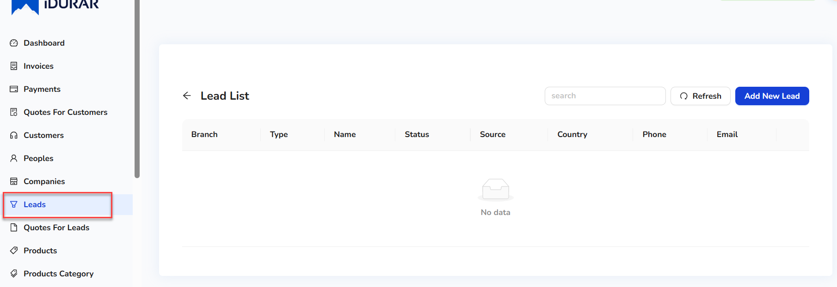
2. Users can see the existing lead list.
3. To add the new lead, click on the Add New Lead button.  
     
   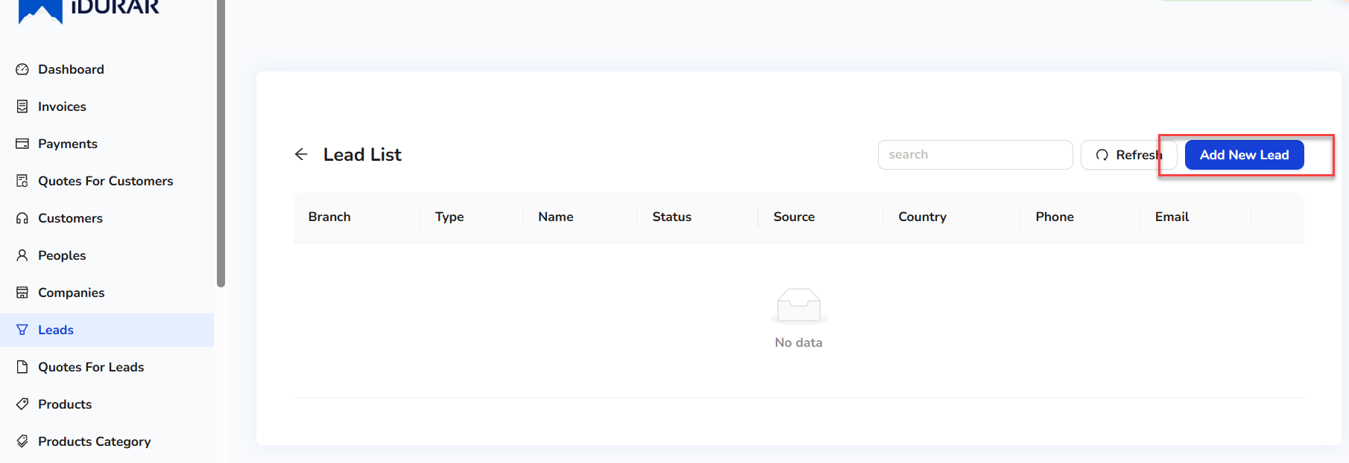
4. On clicking the Add New Lead button, a quick side form will open.  
   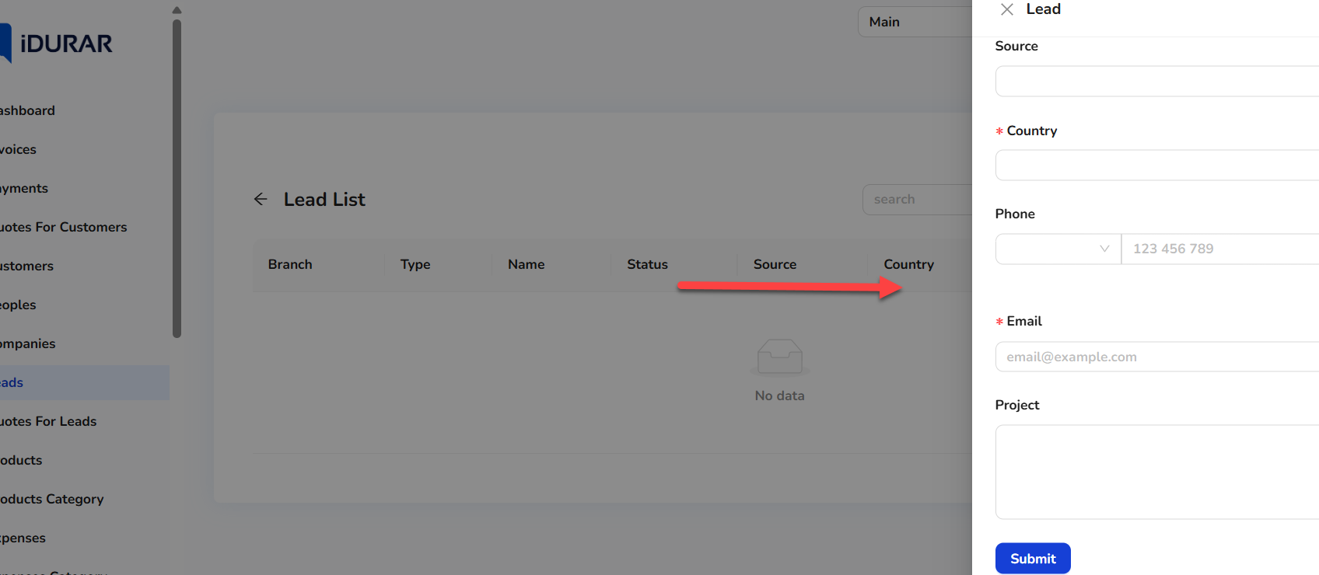
5. Enter the details.
6. Click on the Submit button.  
     
   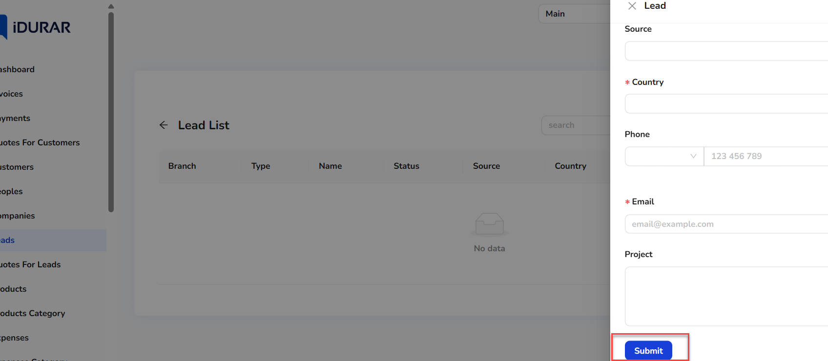
7. Once the new lead record is created, it will show in the lead list.

### **Quotes for Leads**

The Quotes for Leads module enables the creation of sales quotations specifically tied to potential customers (leads). It facilitates sending professional price estimates during the pre-sales stage. This helps track interest, streamline follow-ups, and improve conversion by offering clear and structured pricing proposals linked to lead records.

1. To add quotes for leads, from the left-side menu, select Quotes for Lead.  
     
   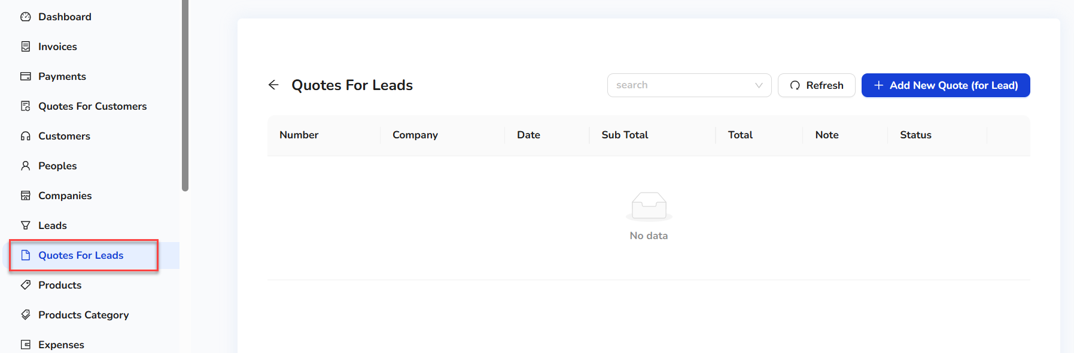
2. Users can see the existing Quotes for Lead list.
3. To add the new lead, click on the Add New Quote (for Lead) button.  
     
   
4. On clicking the Add New Quote (for Lead), a form will open.  
   
5. Enter the details.
6. Click on the Save button.  
     
   
7. Once the new record is created, it will show in the Quotes for Lead list.

### **Products**

The Products screen is used to manage the inventory or services offered. Each product has attributes such as category, price, and tax rates. It integrates with invoicing and expense tracking to maintain accurate records.

1. To add a product, from the left-side menu, select Products.  
     
   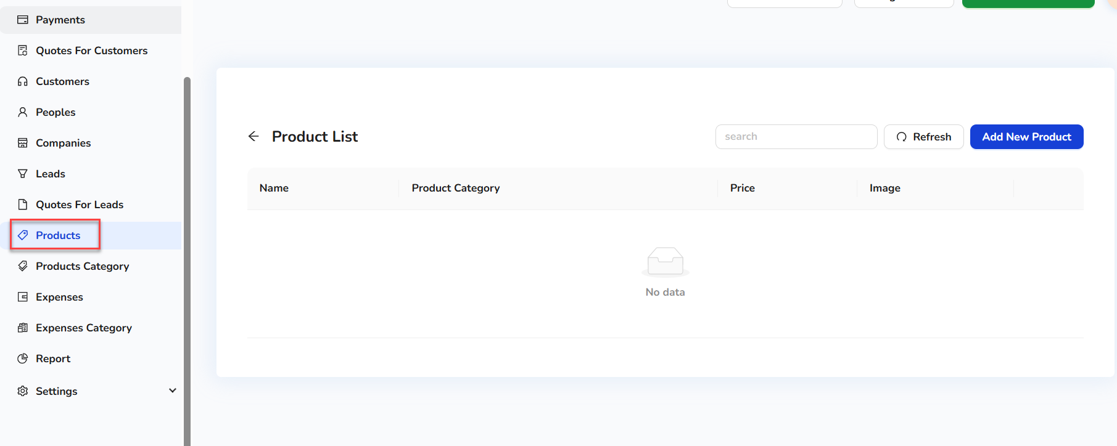
2. Users can see the existing product in the product list (if it exists in the system).
3. To add the new product, click on the Add New Product button.  
     
   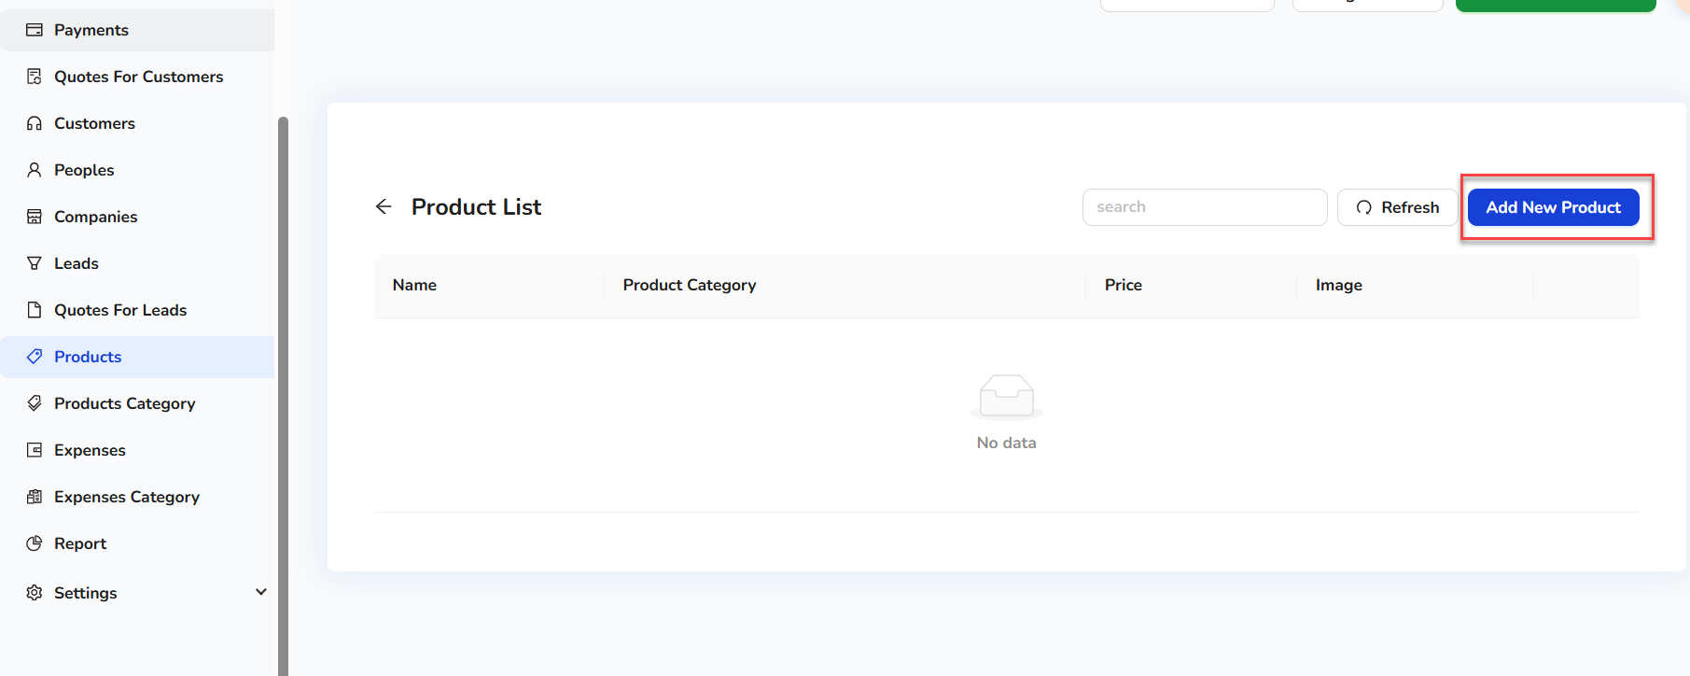
4. On clicking the Add New Product button, a quick side form will open.  
     
   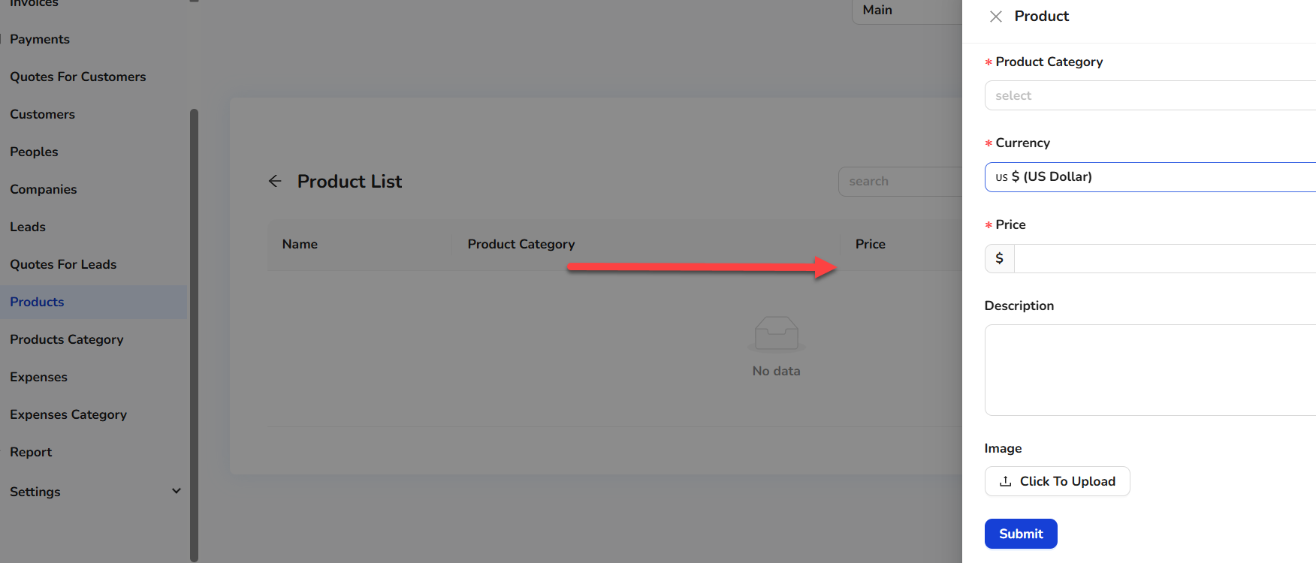
5. Enter the product details.
6. Click on the Submit button.  
     
   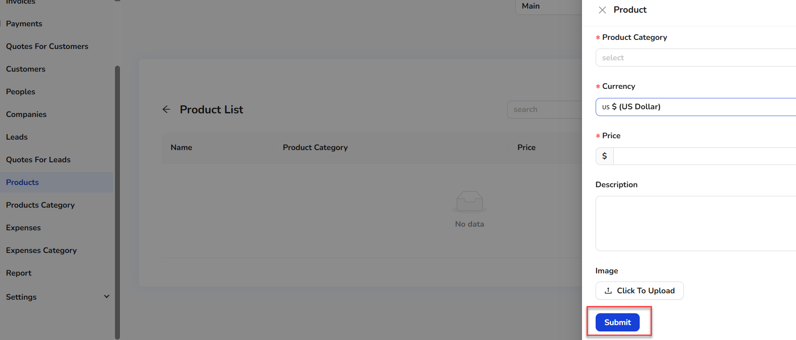
7. Once the new product record is created, it will show in the product list and product lookups.

### **Products Category**

Product categories allow grouping of products for better organization and reporting. This classification aids in product filtering, stock management, and category-wise financial summaries.

1. To add a product category, from the left side menu, selectProducts Category.  
     
   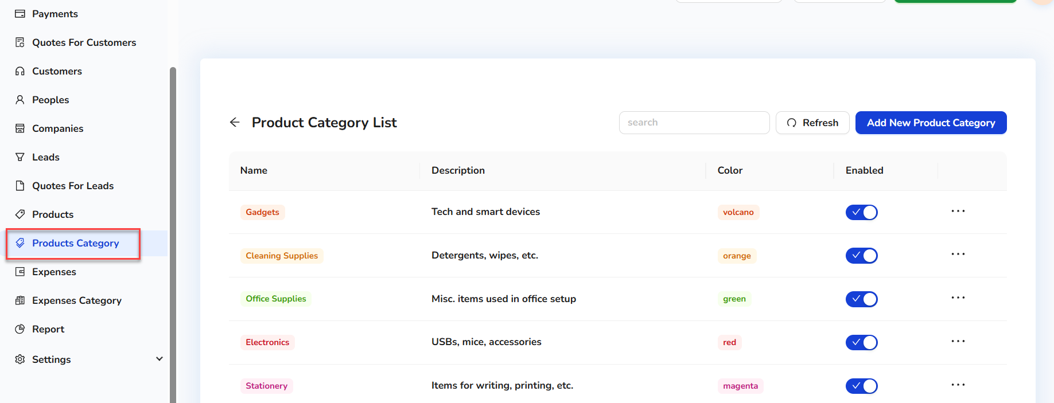
2. Users can see the existing product category list.
3. To add the new product category, click on the Add New Product Category button.  
     
   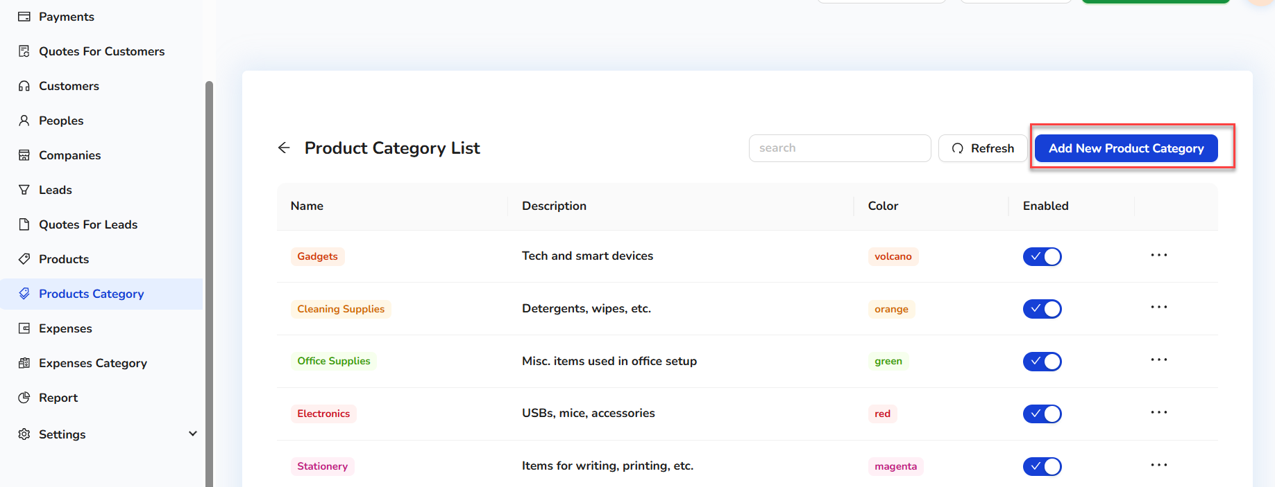
4. On clicking the Add New Product Category button, a quick side form will open.  
     
   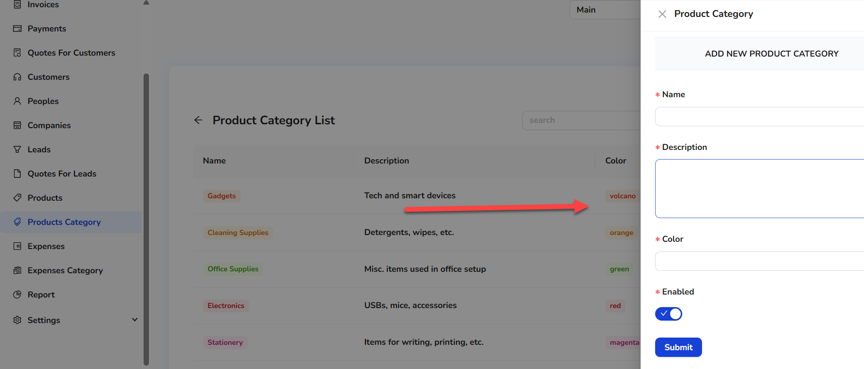
5. Enter the product category details.
6. Click on the Submit button.  
     
   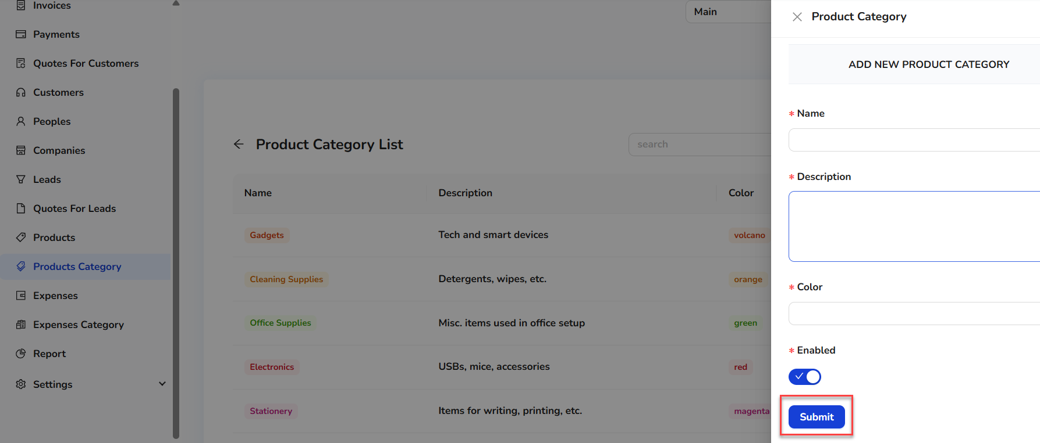
7. Once the new product category record is created, it will show in the product category list and product category lookups.

### 

### **Expense**

The Expense module allows users to log and monitor company expenditures. Users can input costs, associate them with vendors or projects, and assign categories, enabling accurate expense management and budgeting.

1. To add an expense, from the left-side menu, select Expense.  
   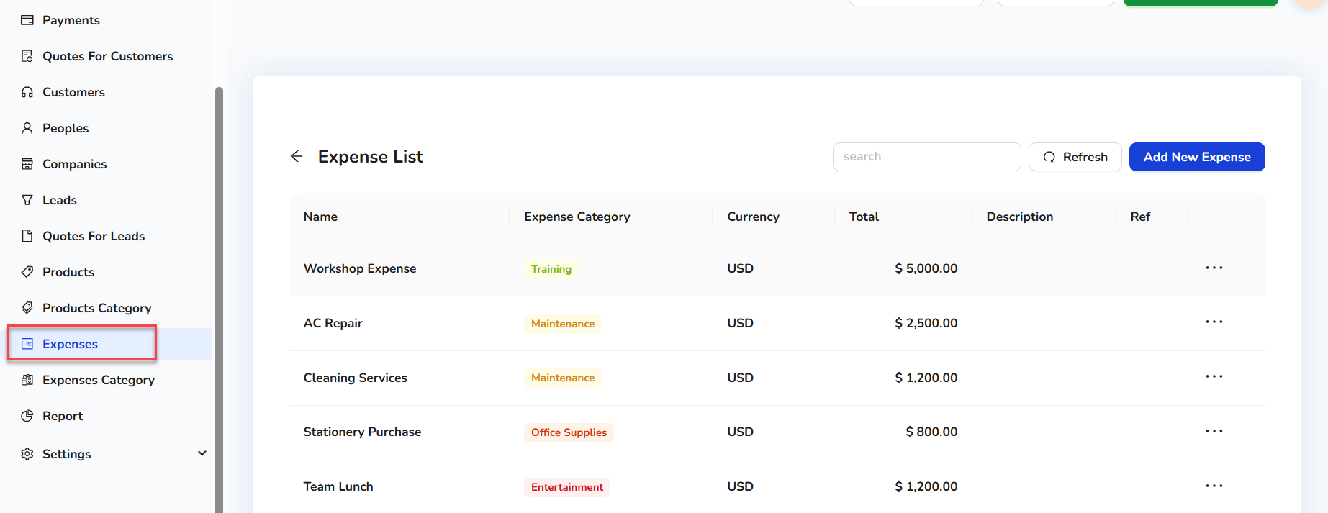
2. Users can see the existing expense list.
3. To add the new expense, click on the Add New Expense button.  
     
   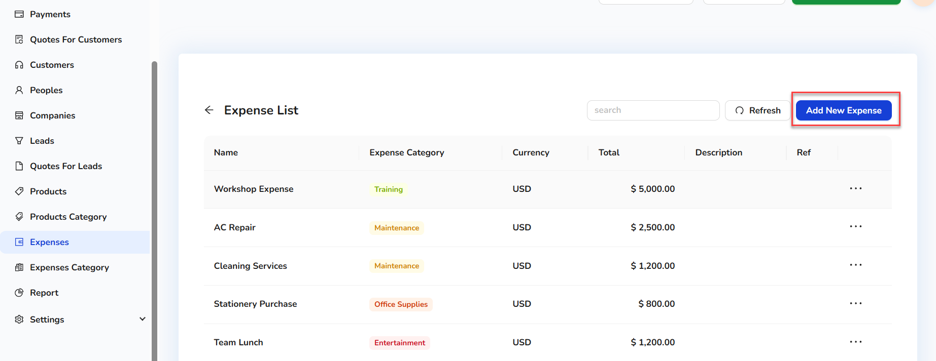
4. On clicking the Add New Expense, a quick side form will open.  
     
   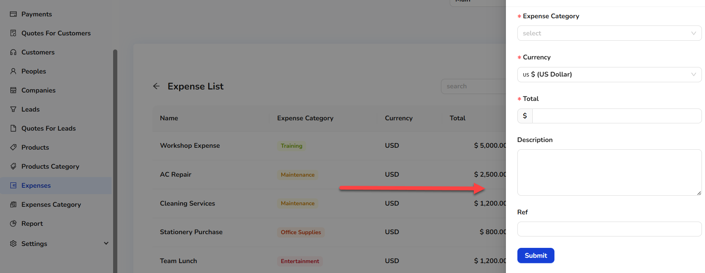
5. Enter the details.
6. Click on the Submit button.  
     
   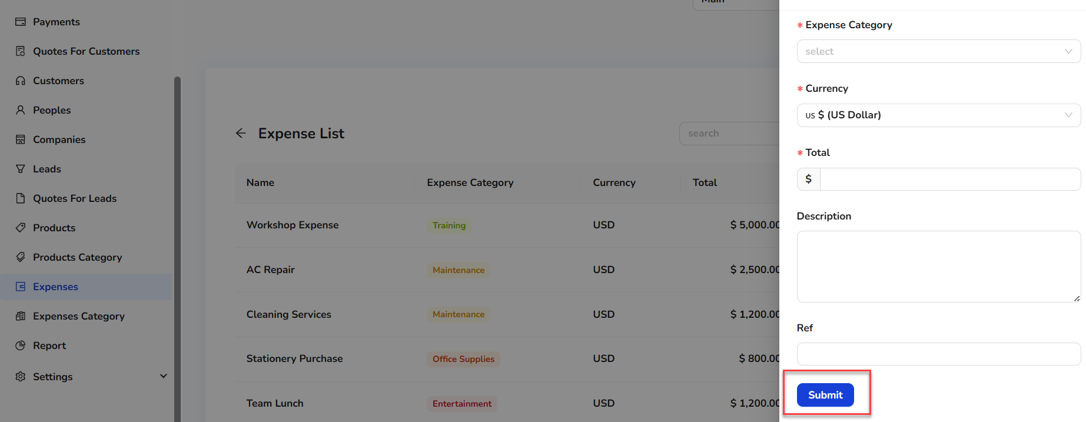
7. Once the new expense record is created, it will show in the expense category list and expense category lookups.

### **Expense Category**

Similar to product categories, expense categories help organize and classify business expenses. This assists in budget tracking, expense reporting, and financial audits.

1. To add an expense category, from the left-side menu, select Expense Category.  
   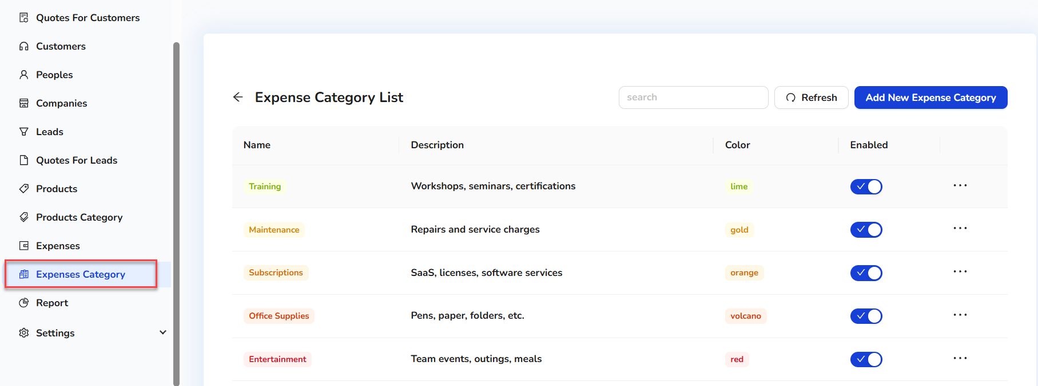
2. Users can see the existing expense category list.
3. To add the new expense category, click on the Add New Expense Category button.  
     
   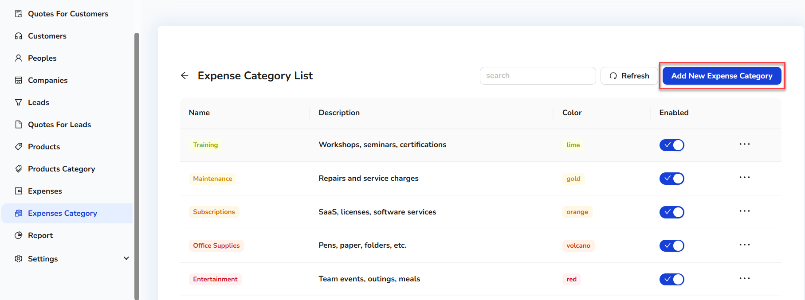
4. On clicking the Add New Expense Category, a quick side form will open.  
   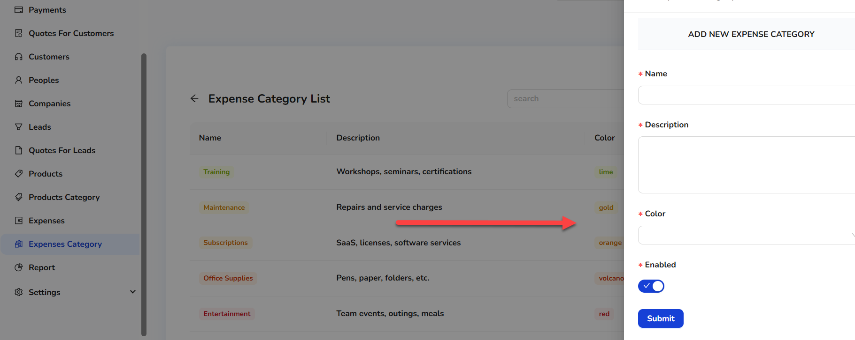
5. Enter the details.
6. Click on the Submit button.  
     
   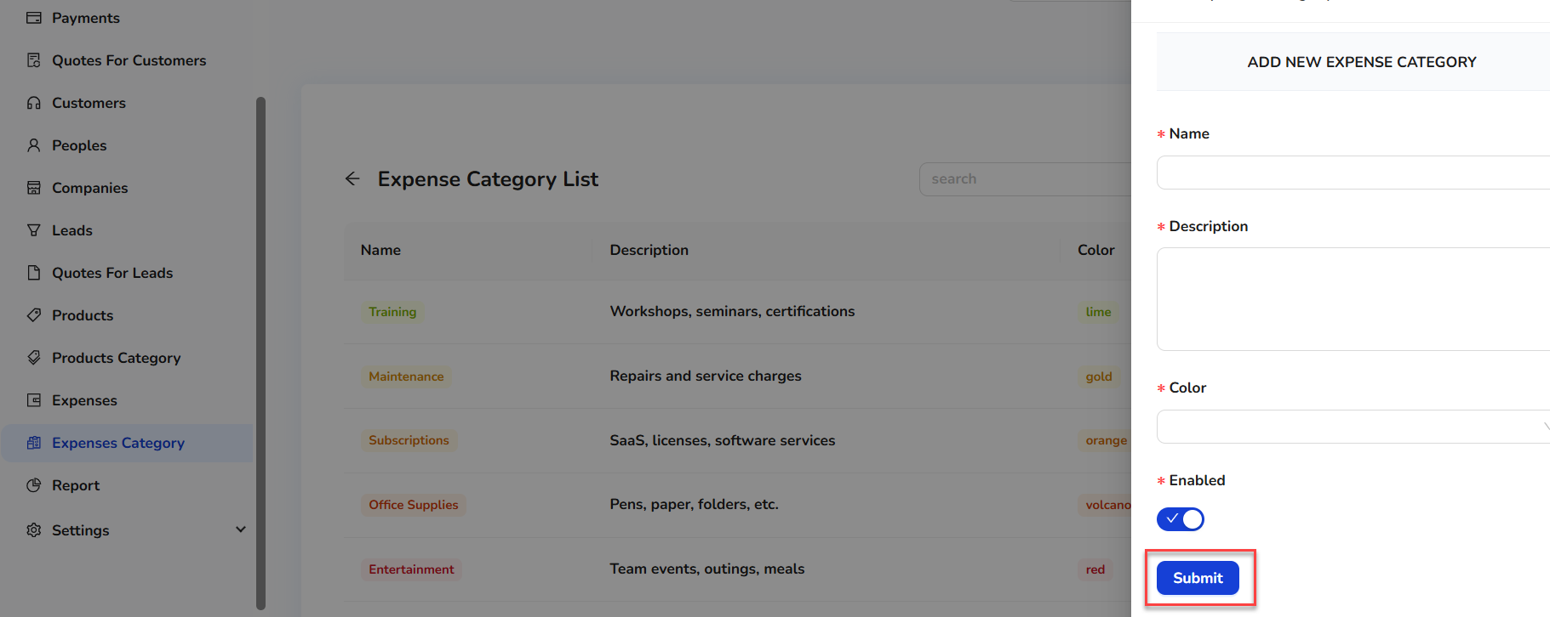
7. Once the new expense category record is created, it will show in the expense category list and expense category lookups.

### **System Reports**

IDURAR provides visual reports for:

| **Report Type** | **Location** | **Format/Usage** |
| --- | --- | --- |
| Paid Invoice | Report | Bar Chart |
| Unpaid Invoice | Report | Bar Chart |
| Proforma Invoice | Report | Bar Chart |
| Offer | Report | Bar Chart |

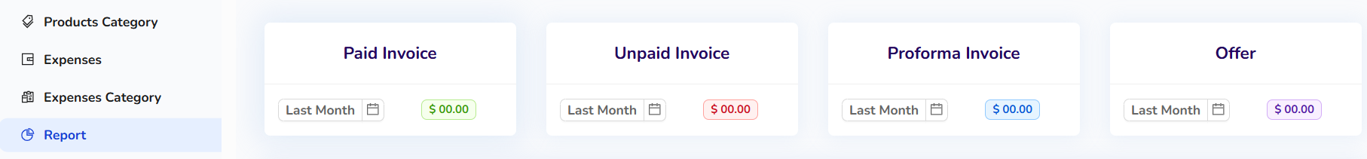

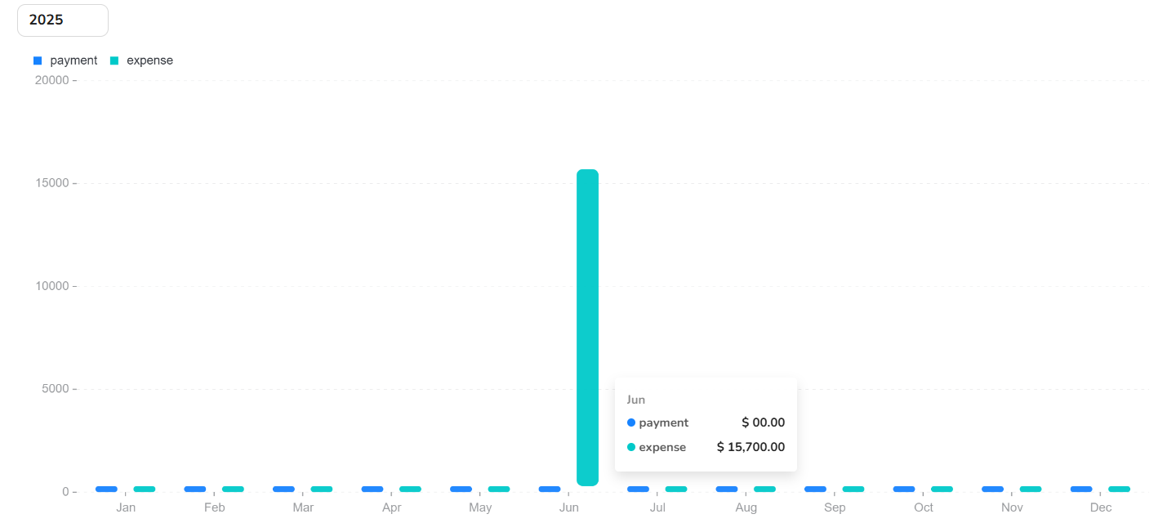

### **Settings**

The Settings section provides configuration options for the ERP/CRM system. It includes company settings, tax configuration, email templates, system-wide preferences, and other options critical to customizing the platform for specific business needs.

1. From the left side menu, click on Setting.

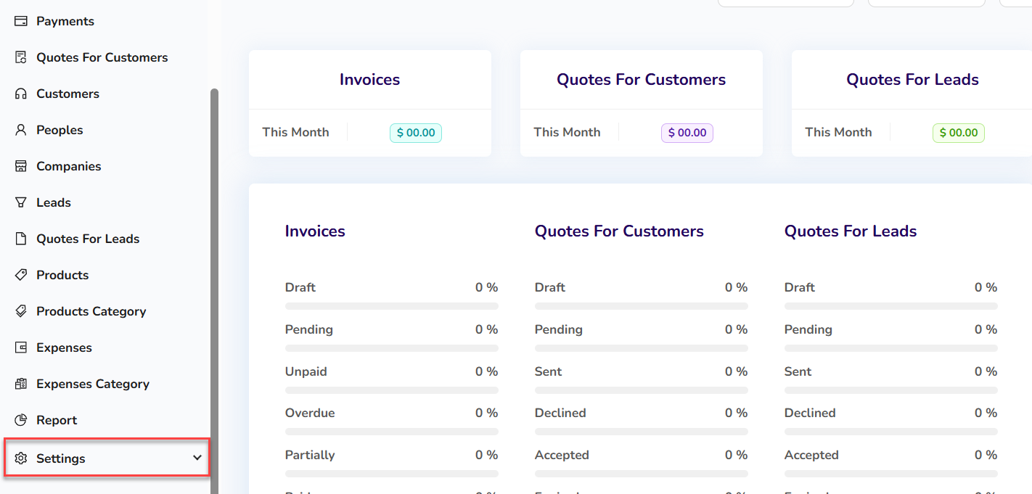

1. All the settings options will display under Settings tab.   
     
   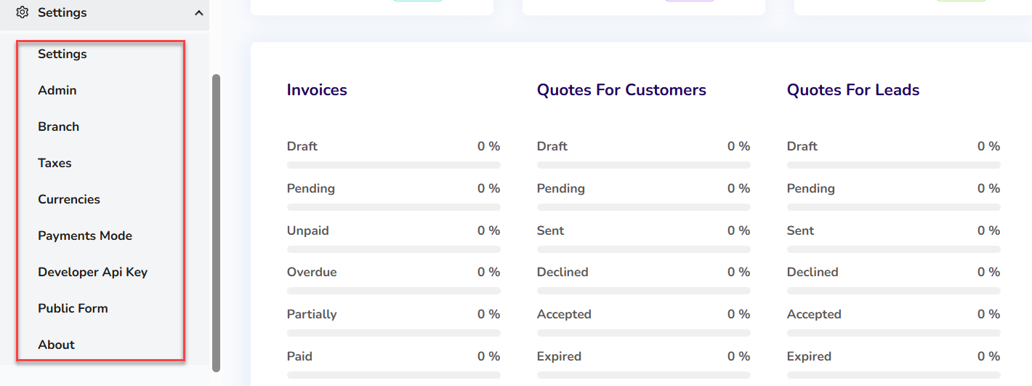

**Settings**

User can also change System settings (change language, logo, currency, etc.)

1. Click on Settings.
2. User can change App Settings (like Language, Country, PDF settings, Logo)  
     
   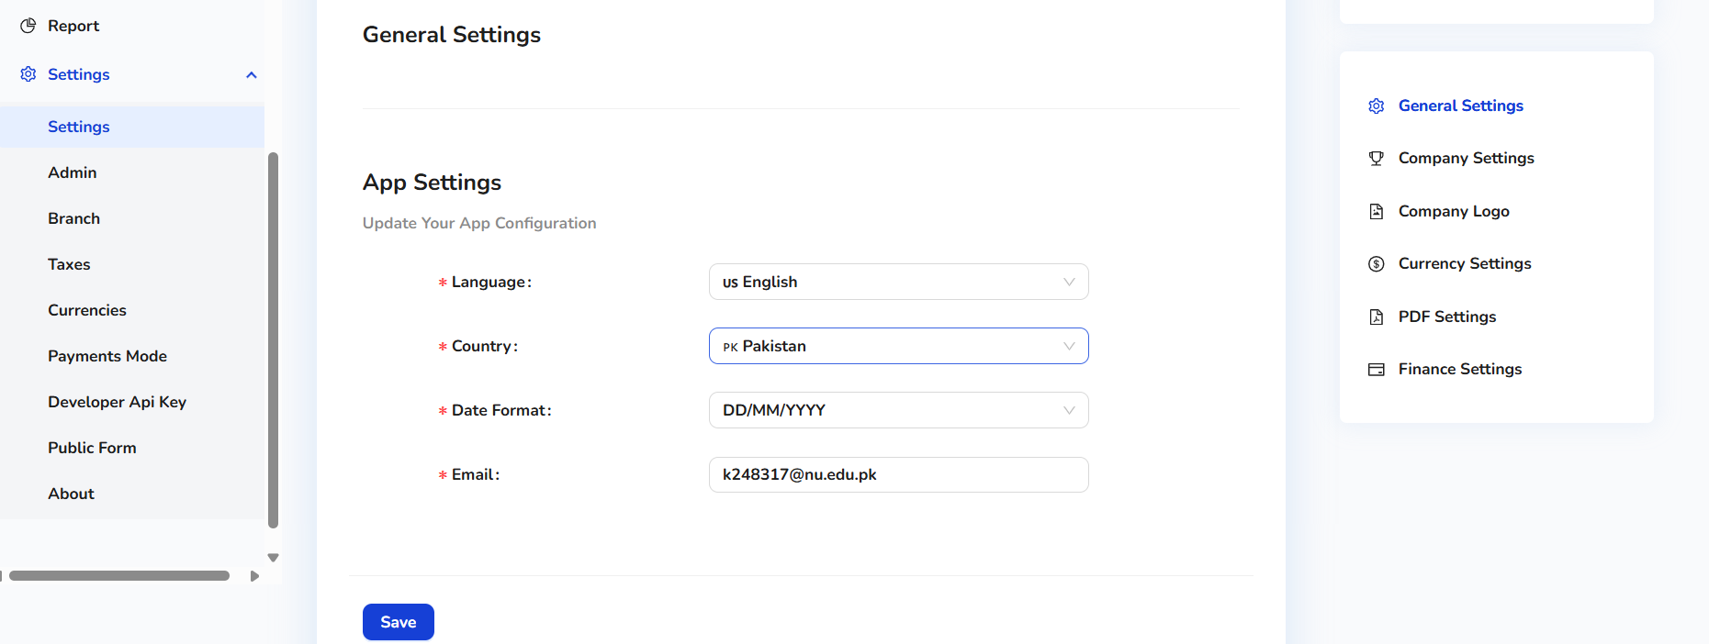

**Admin**

1. Users can also add an admin (if they have rights).
2. Click on Admin.  
     
   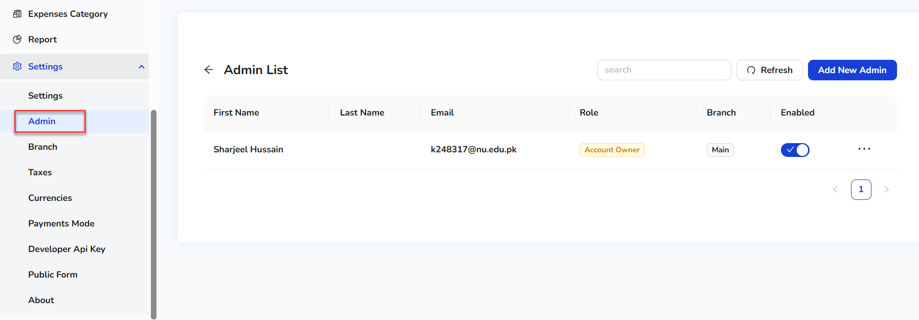
3. Users can see the existing admin list.
4. To add the new admin, click on the Add New Admin button.  
   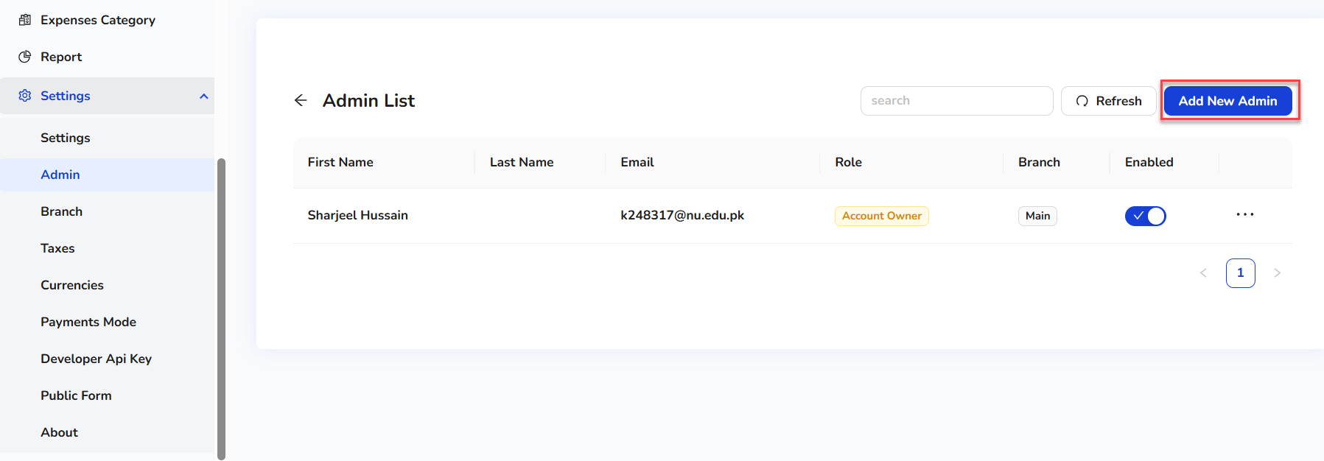
5. On clicking the Add New Admin button, a quick side form will open.  
     
   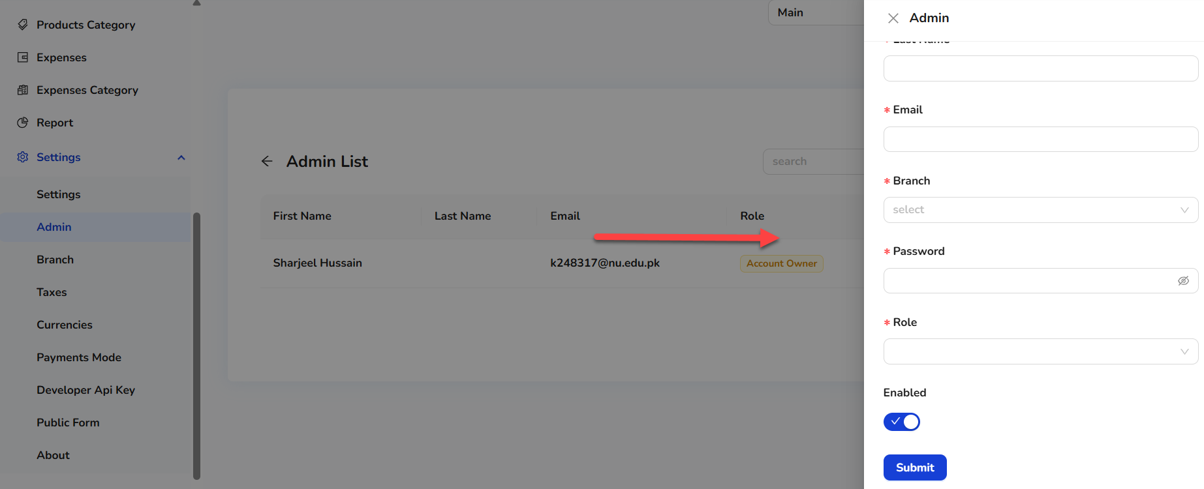
6. Enter the details.
7. Click on the Submit button.  
   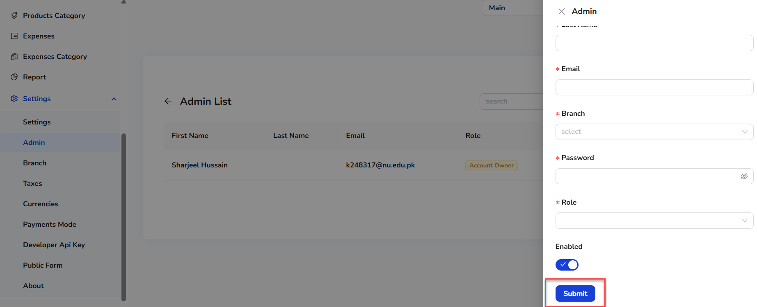
8. Once the new admin record is created, it will show in the admin list.

**Branch**   
  
users can also add a branch (if they have rights).

1. Click on Branch.  
   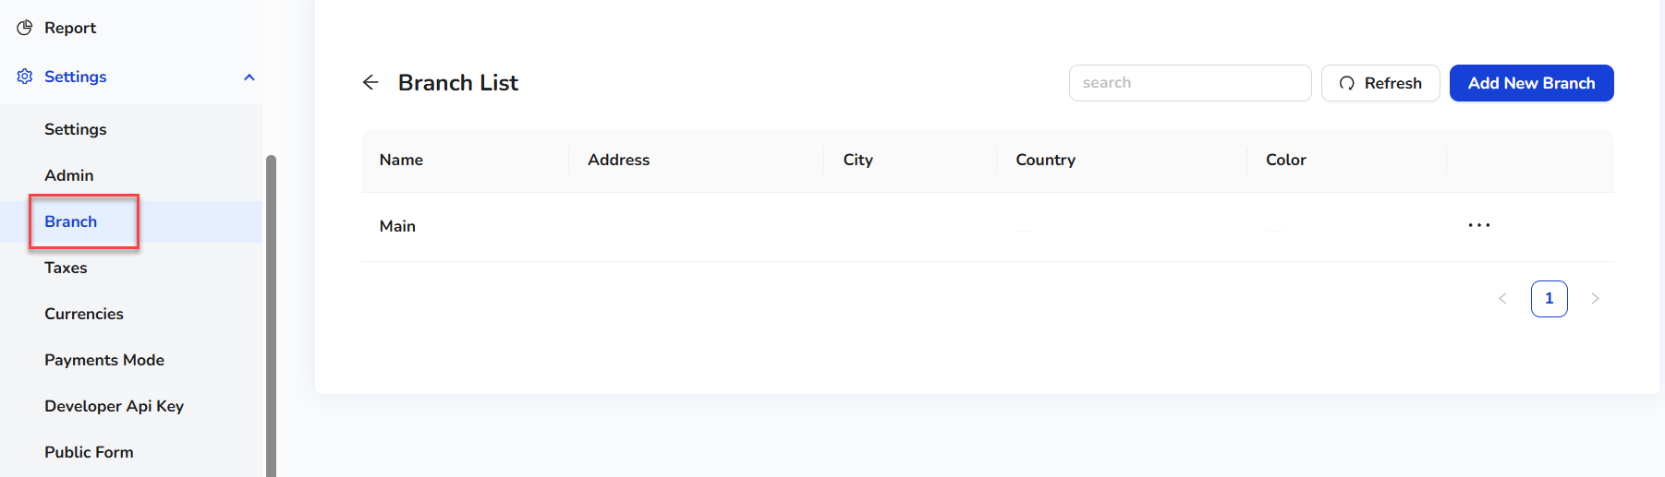
2. Users can see the existing branch list.
3. To add the new branch, click on the Add New Branch button.  
     
   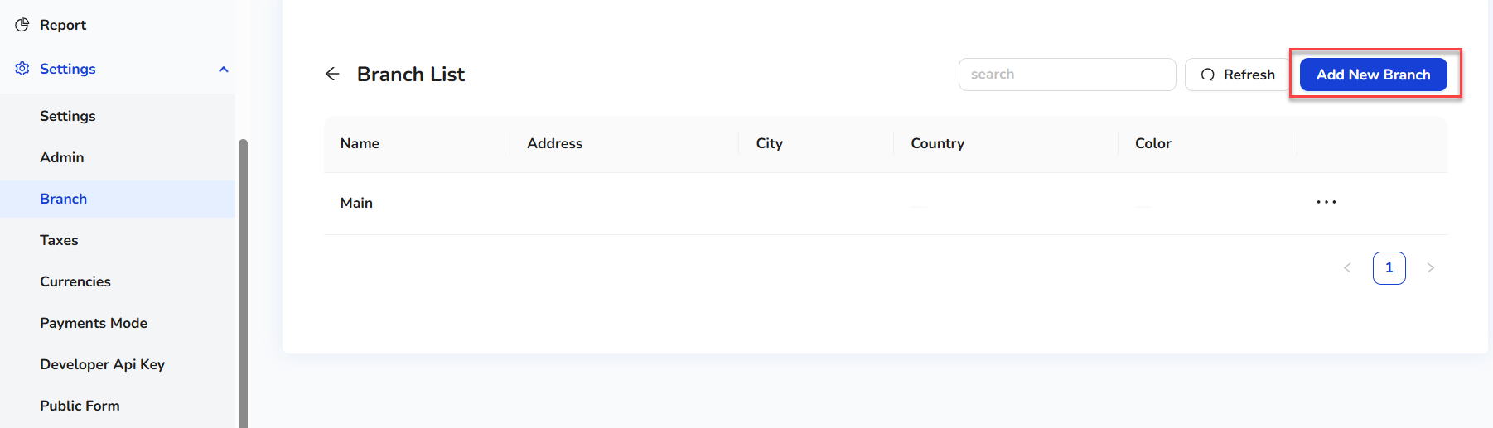
4. On clicking the Add New Branch button, a quick side form will open.  
   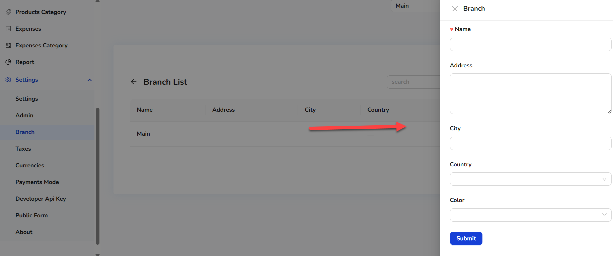
5. Enter the details.
6. Click on the Submit button.  
   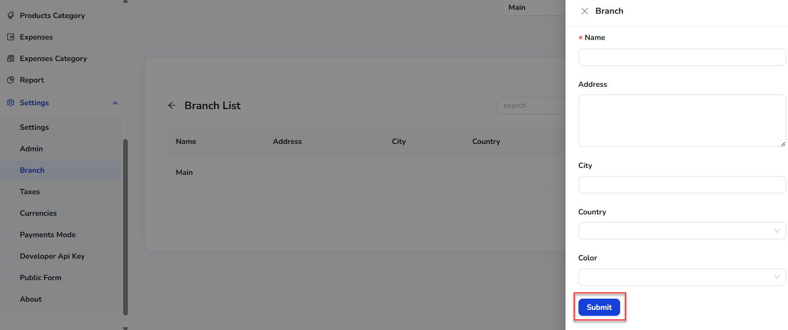
7. Once the new branch record is created, it will show in the branch list.

**Taxes**  
  
Users can also add taxes (if they have rights).

1. Click on Taxes.  
   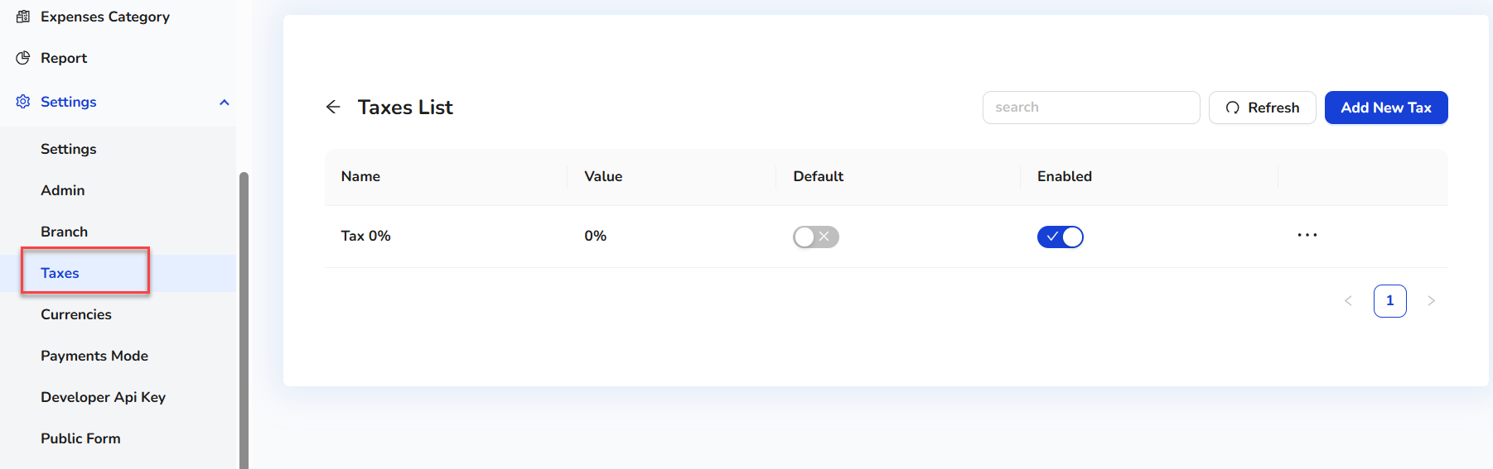
2. Users can see the existing taxes list.
3. To add the new taxes, click on the Add New Taxes button.  
   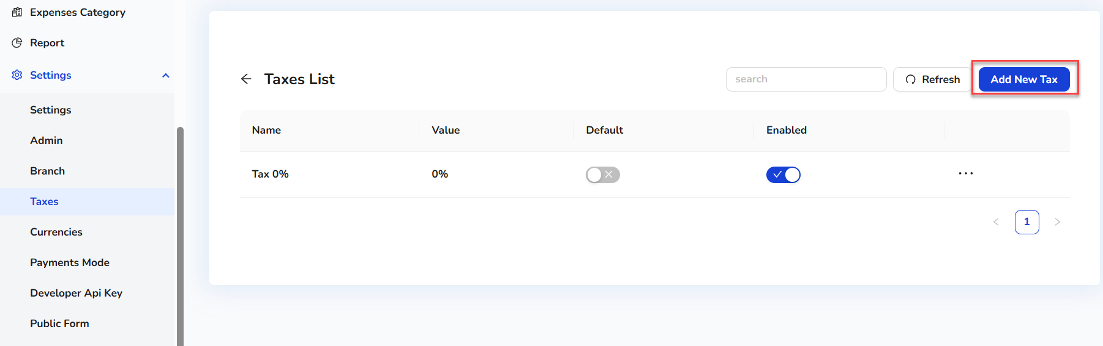
4. On clicking the Add New Taxes button, a quick side form will open.  
     
   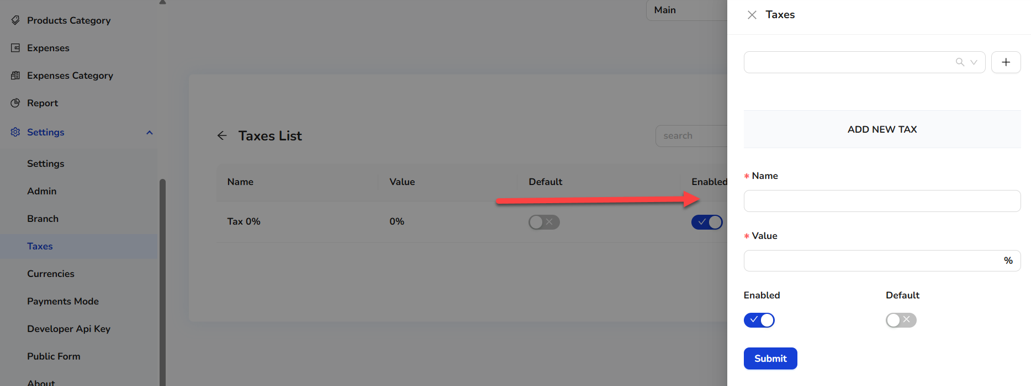
5. Enter the details.
6. Click on the Submit button.  
     
   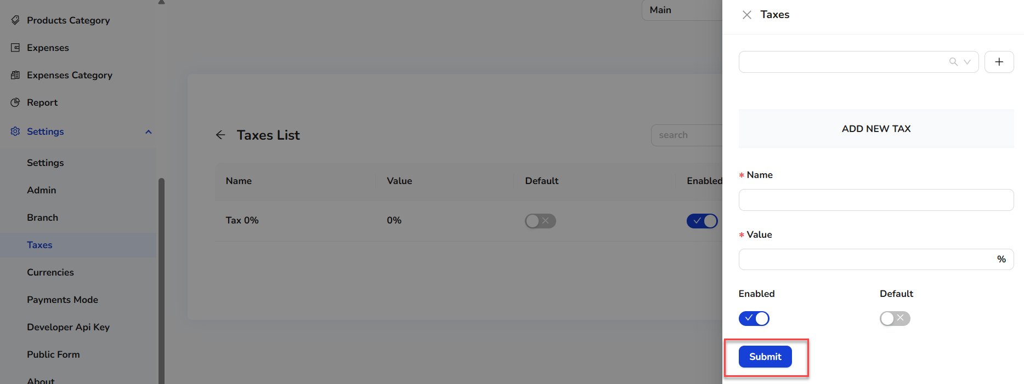
7. Once the new taxes record is created, it will show in the taxes list.

**Currencies**   
  
Users can also add currencies (if they have rights).

1. Click on Currencies.  
   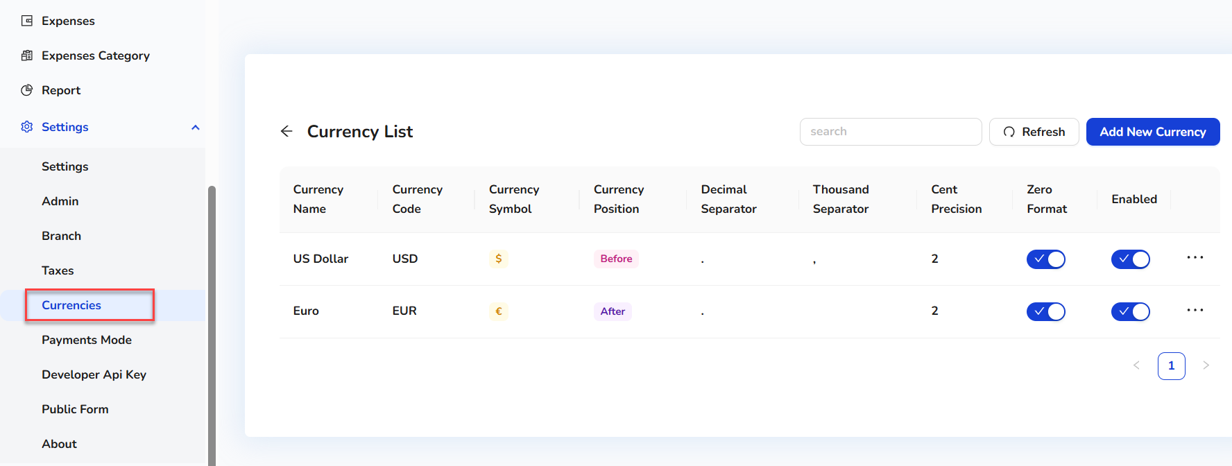
2. Users can see the existing currency list.
3. To add the new currency, click on the Add New Currency button.  
   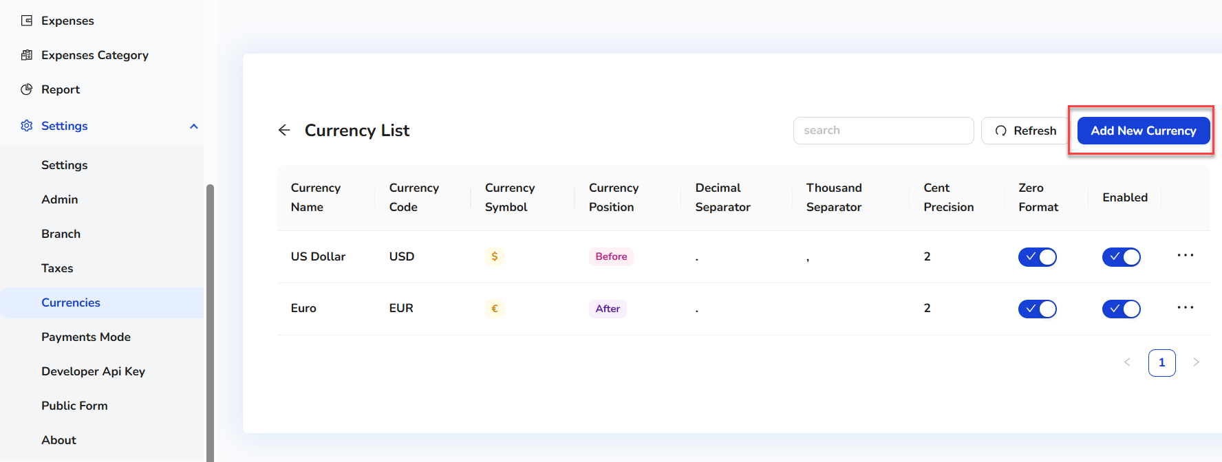
4. On clicking the Add New Currency button, a quick side form will open.  
   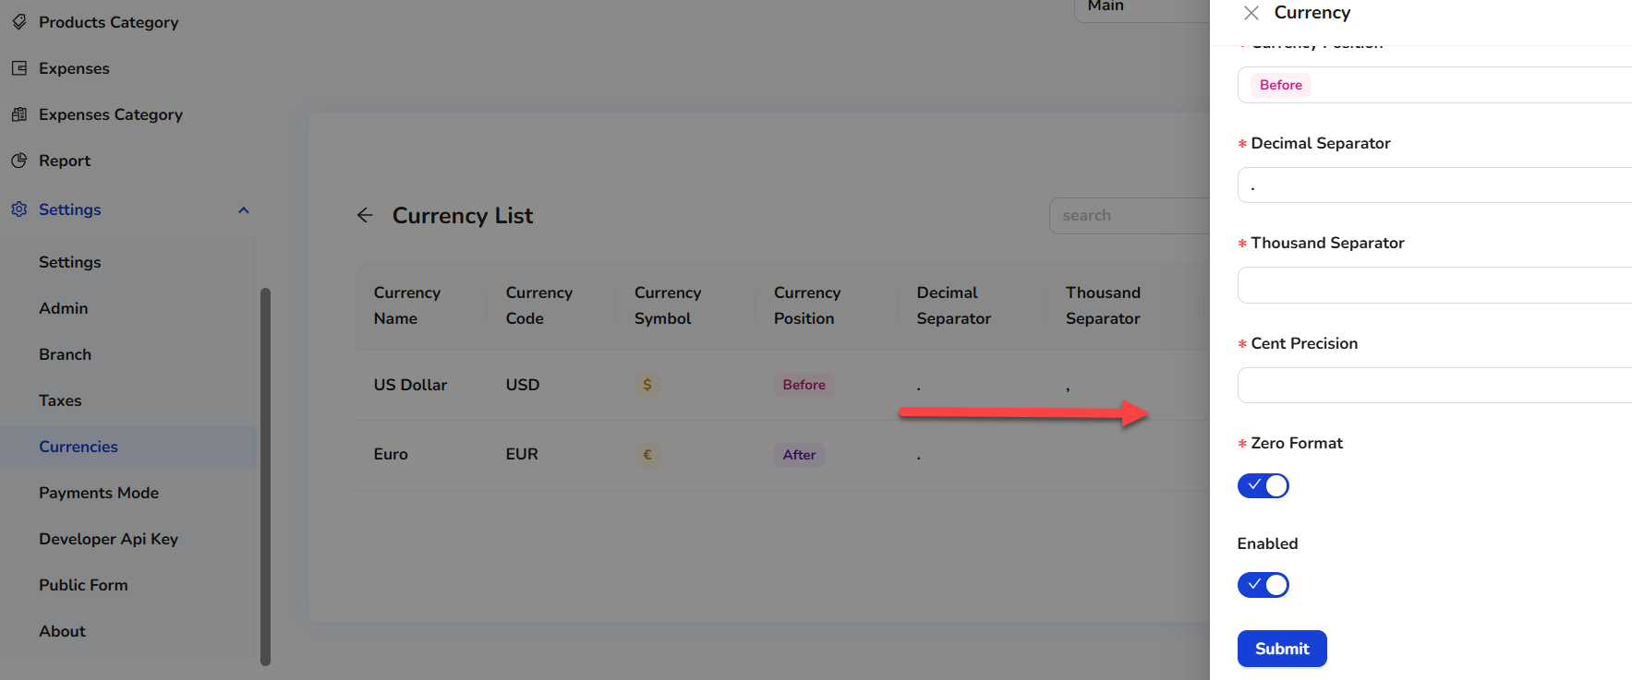
5. Enter the details.
6. Click on the Submit button.  
     
   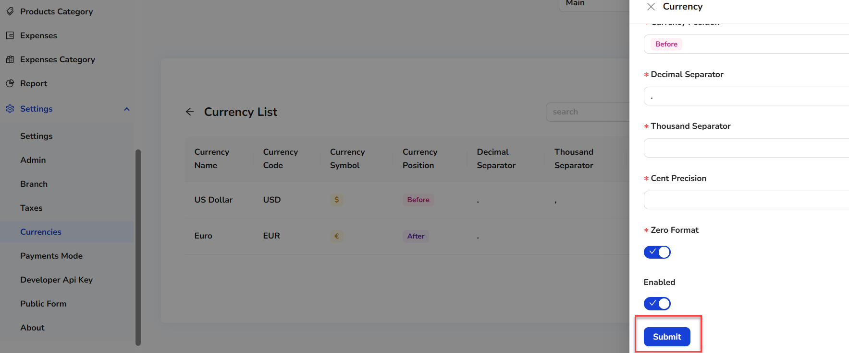
7. Once the new currency record is created, it will show in the currency list.

**Payments Mode**   
  
Users can also add payment modes (if they have rights).

1. Click on Payment Mode.  
   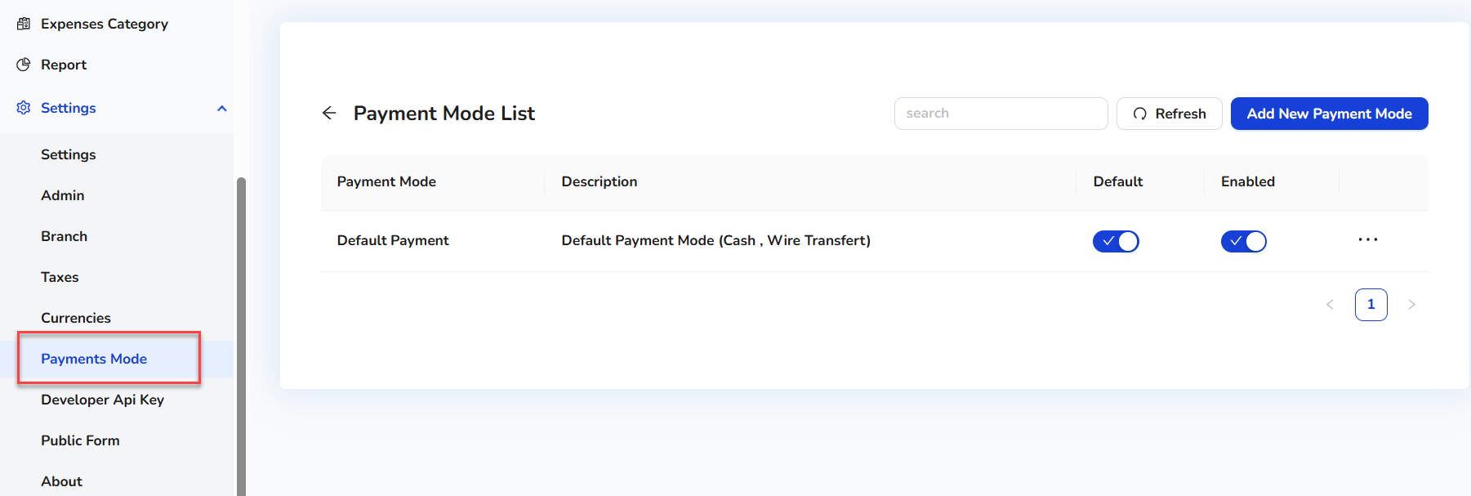
2. Users can see the existing payment mode list.
3. To add the new payment mode, click on the Add New Payment Mode button.  
     
   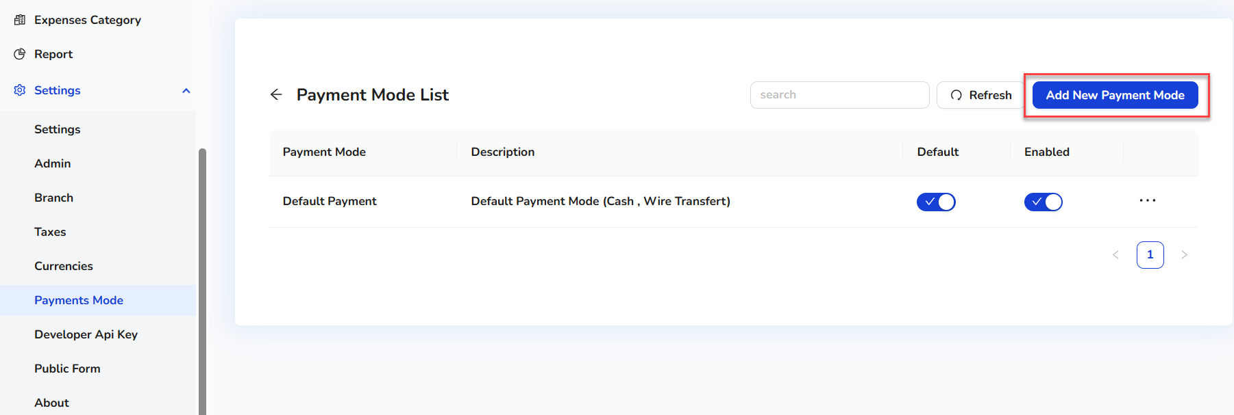
4. On clicking the Add New Payment Mode button, a quick side form will open.  
   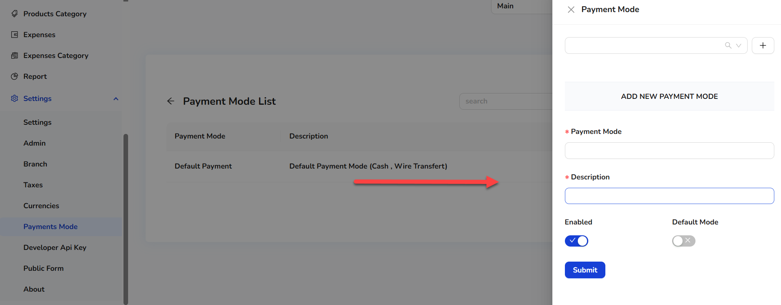
5. Enter the details.
6. Click on the Submit button.  
   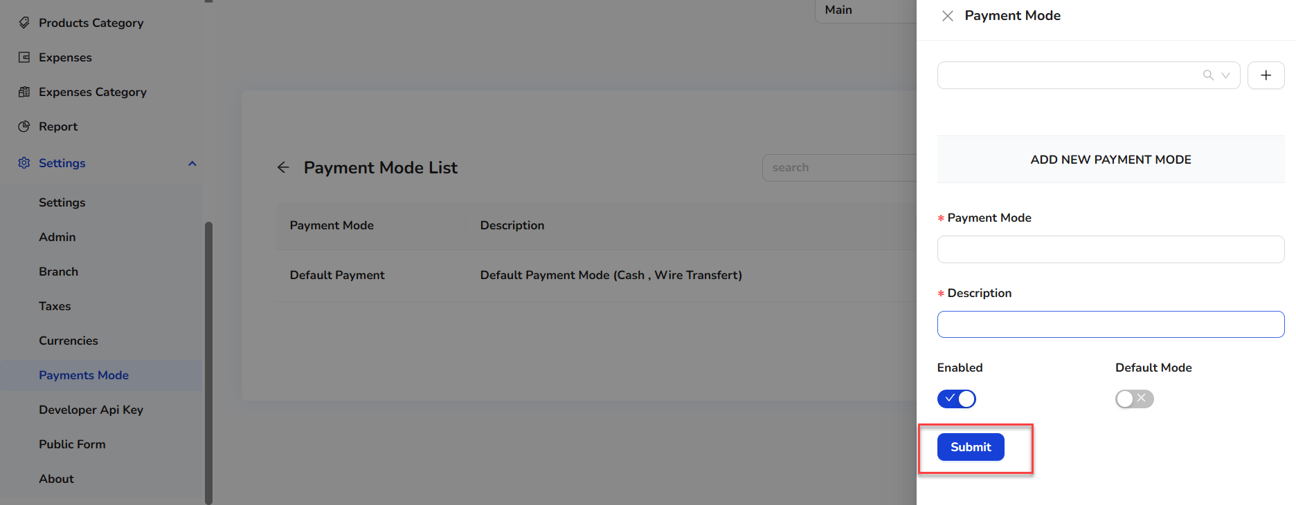
7. Once the new payment mode record is created, it will show in the payment mode list.

**Developer API Key**   
  
Users can also add a Developer API Key (if they have rights).

1. Click on Developer API Key.  
   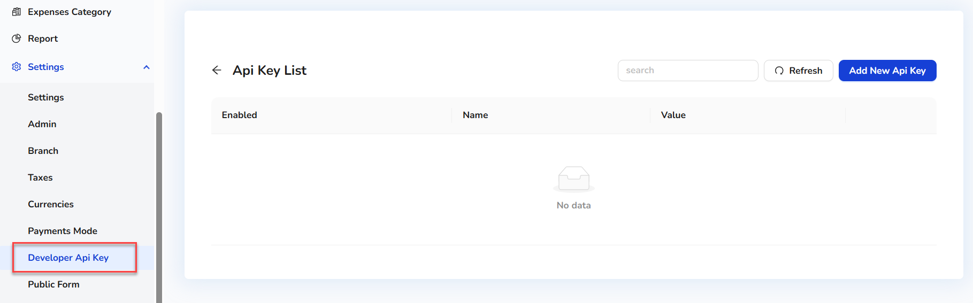
2. Users can see the existing Developer API Key list.
3. To add the new Developer API Key, click on the Add New Developer API Key button.  
     
   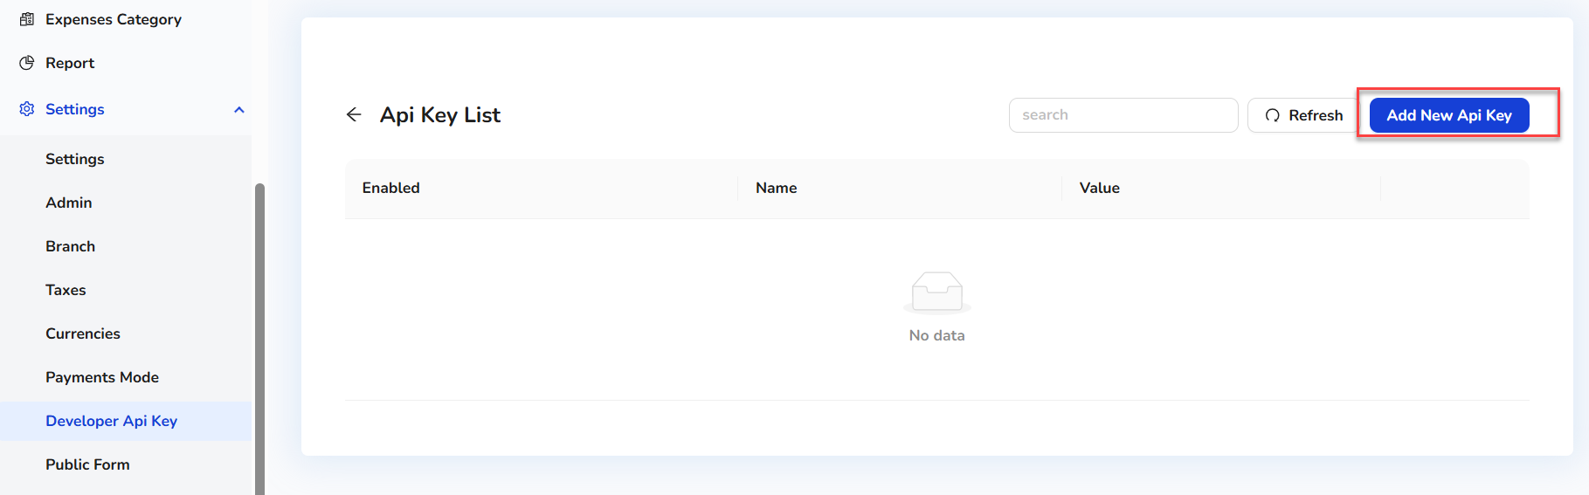
4. On clicking the Add New Developer API Key button, a quick side form will open.  
   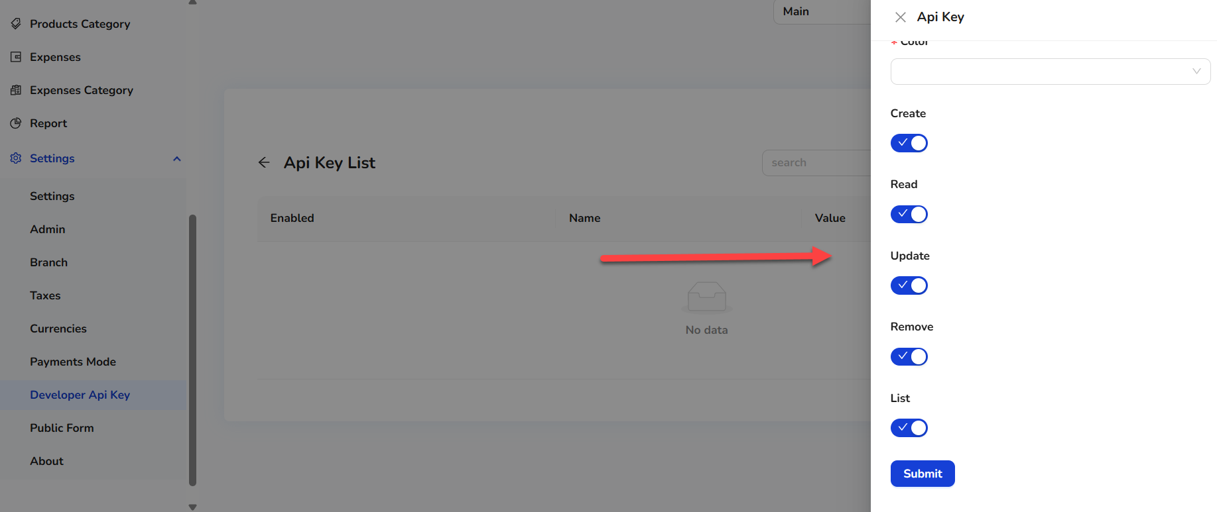
5. Enter the details.
6. Click on the Submit button.  
     
   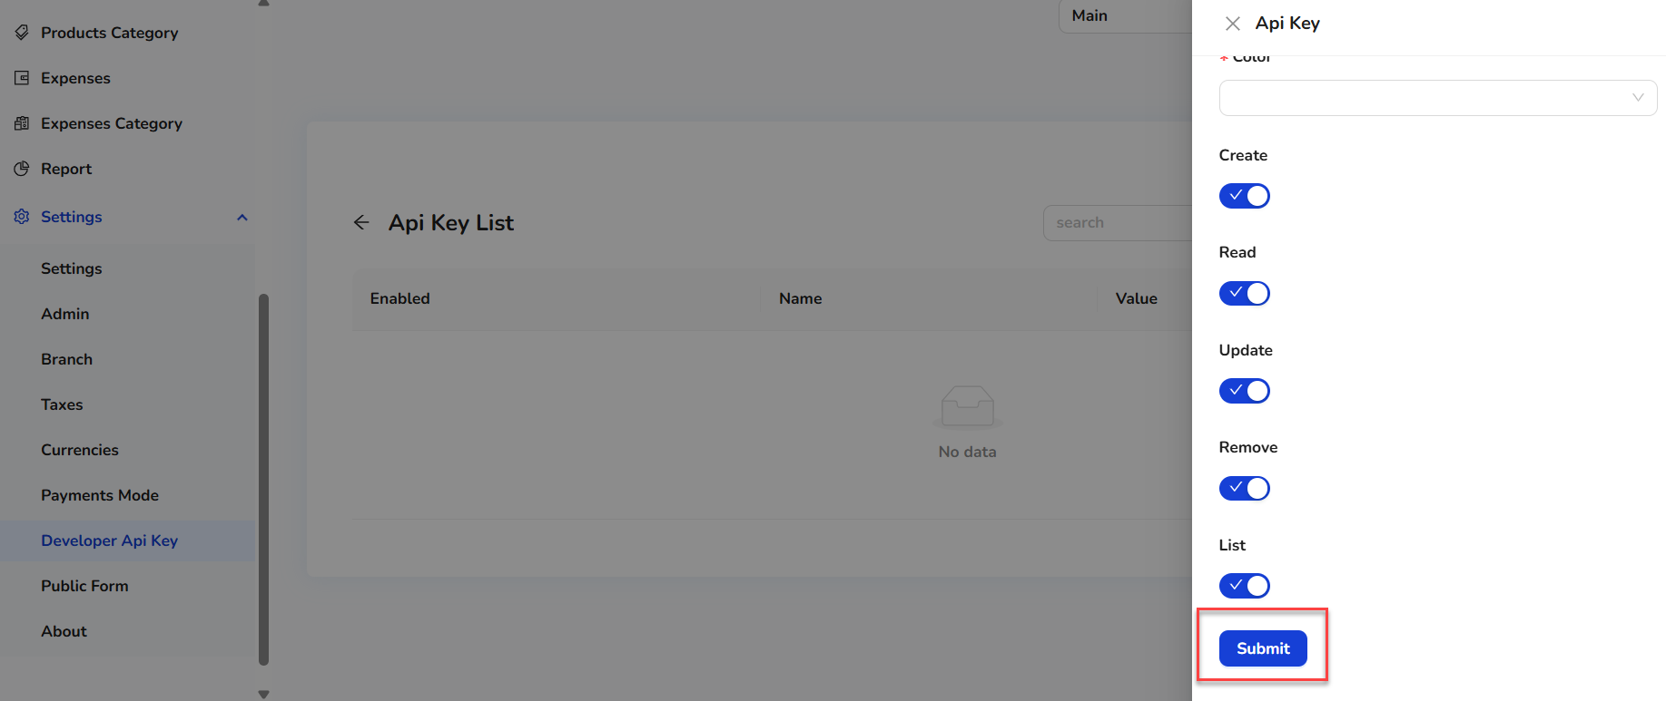

Once the new Developer API Key record is created, it will show in the Developer API Key list.

**Public Form**   
Users can also add a public form (if they have rights).

1. Click on Public Form.  
   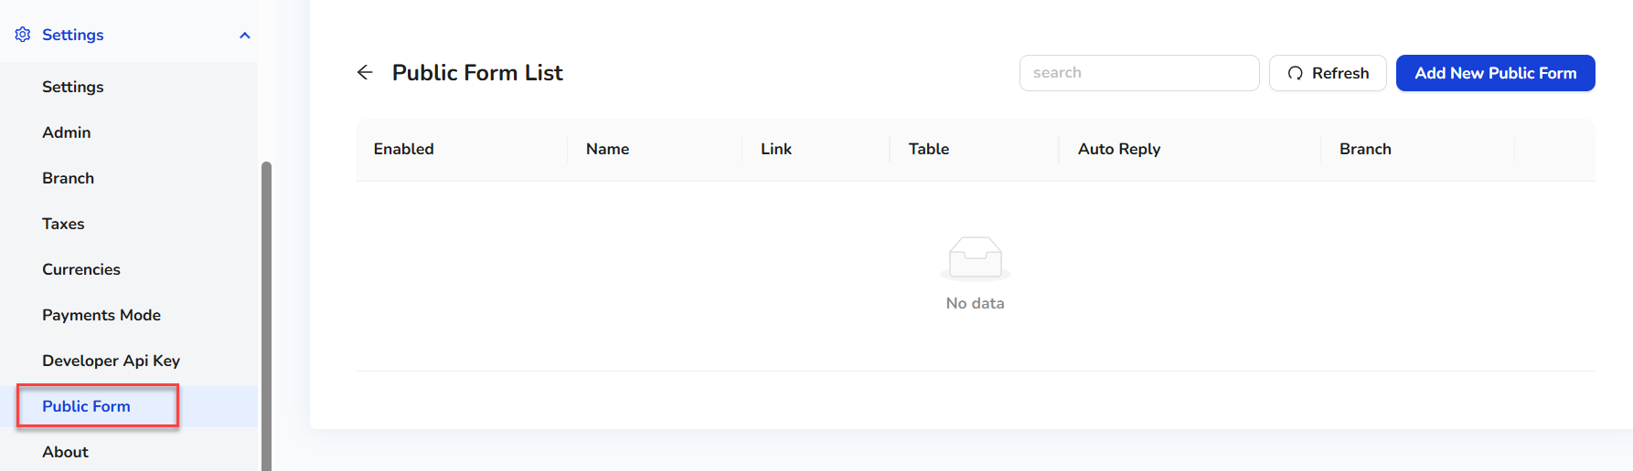
2. Users can see the existing public form list.
3. To add the new public form, click on the Add New Public Form button.  
   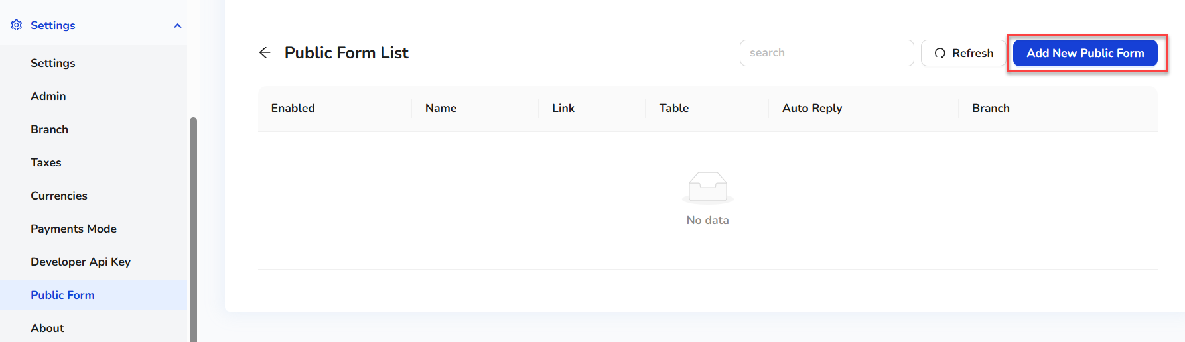
4. On clicking the Add NewPublic Form button, a quick side form will open.  
   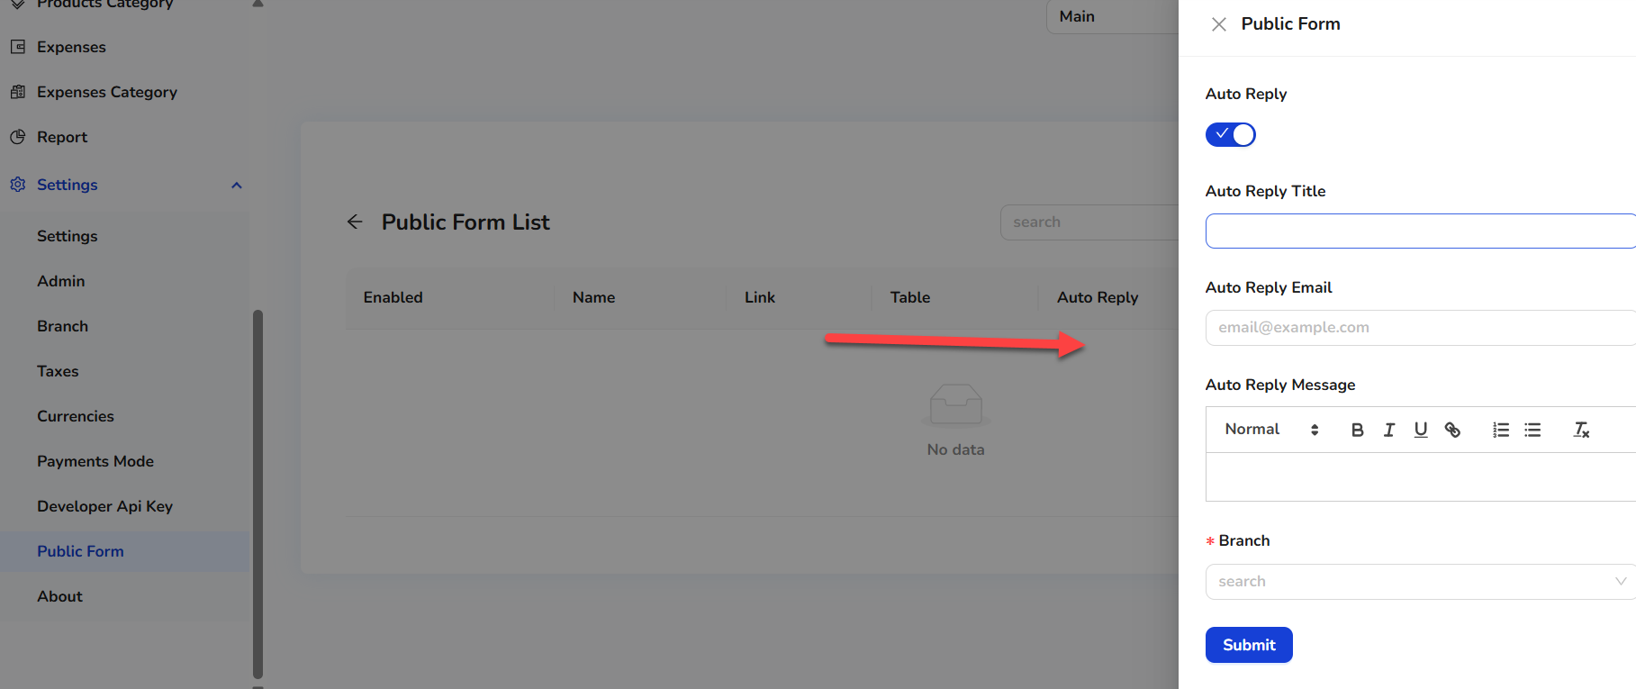
5. Enter the details.
6. Click on the Submit button.  
   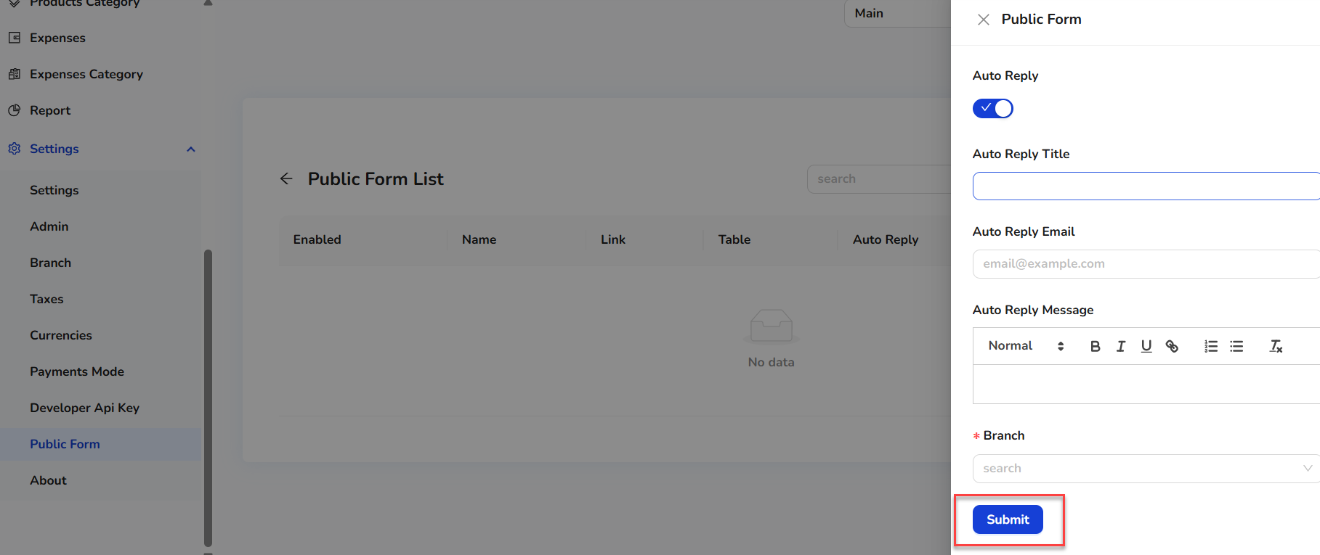
7. Once the new public forum record is created, it will show in the public forum list.

**About**   
  
Users will also get information about System.  
